PANDUIT ® Introduces Innovative LC System Solution
February 2004, Tinley Park, IL -- Panduit Corp. introduces an LC System Solution that meets the demands of high-density fiber optic networks. The LC system components provide superior durability and fast, easy installation and management.  PANDUIT LC Multimode and Singlemode Connectors feature an innovative rear pivot “anti-snag” latch design with a wide “positive grip” thumb latch to provide longer latch cycle life and better control during mating and unmating. A single connector design is used for simplex and duplex patch cords, and for applications inside the wall. An efficient polishing procedure and anaerobic adhesive termination simplify and dramatically reduce installation time compared to heat cured epoxy terminations. The duplexing clip is field installable without tools, and includes polarity markers for quick polarity identification and changes. An audible “click” provides the user with a definitive signal that the connector has been successfully mated. | 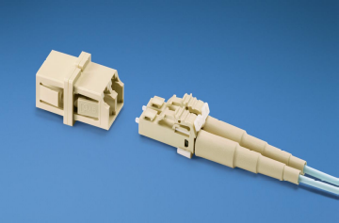
PANDUIT LC Patch Cords, Pigtails and Hybrid Patch Cords are available on Singlemode 9µm (OS1) fiber and Multimode 62.5µm (OM1), 50µm (OM2) and OPTI-CORE™ 10GIG™ 50µm (OM3) fiber. PANDUIT LC Sr./Sr. and Sr./Jr. Simplex and Mini Duplex Adapters feature integrated panel retention clips and superior weld strength for improved mounting and durability. The Jr. interface of LC Sr./Jr. Adapters also accommodates fixed ferrule LC connectors and tighter applications inside the wall. LC Mini Duplex Adapters fit into SC Simplex Adapter panel openings to double the density in the same rack space. PANDUIT LC Adapters are also available in MINI-COM Modules and OPTICOM Fiber Adapter Panels.
For more information or to request a catalog, contact PANDUIT: 800-777-3300 • cs@panduit.com

