UK Declaration of Conformity

UK Declaration of Conformity
Model Number: | AT-VTP-1000VL

Product Name: | Velocity System 10” VESA Mount Touch Panel with  LED includes Wall Mount Kit

Authorized Manufacturer: | Atlona, Inc.  70 Daggett Drive San Jose, CA 95134 USA  (408) 962-0515

This product conforms with the provisions of the following UK regulations, including all amendments, and with national legislation implementing these regulations.

Regulations: | Electromagnetic Compatibility Regulations 2016  The Restriction of the Use of Certain Hazardous Substances in Electrical and Electronic Equipment Regulations 2012  Radio Equipment Regulations 2017  Electrical Equipment (Safety) Regulations 2016

The following harmonized standards were applied:

Standards: | BS EN 50566  BS EN 50663  ,  BS EN 55032  BS EN 55024

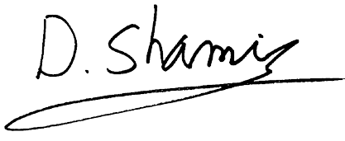
This product carries the UKCA mark, which was affixed in 2021.

Authorized Signatory: | David Shamir, Vice President Product Management

Date: | May 28, 2021

Place: | San Jose, CA, USA

