Industry Leading Fastening Solution
Locks Tight and Stays Tight
TINLEY PARK, IL (June 29, 2007) – New PANDUIT® Pan-Steel® Stainless Steel Retained Tension Ties and Tools deliver a durable, secure fastening solution for mechanical applications. This solution delivers the highest retained tension in the industry, up to two times tighter than alternative designs, for improved reliability. Retained tension ties and tools are designed to work together to ensure consistent installations. Applications include fastening of armored cable, pipe, tubing, conduit, rubber boots and heat shields.  Pan-Steel® Stainless Steel Retained Tension Ties are available in standard, light heavy and heavy cross sections with two design options for maximum application flexibility. The clamp design (MRT series) provides tight fastening of rigid materials in high vibration and harsh environments. For fluid applications, the 360°seal design (MRS series) eliminates gaps under the head of the tie, delivering a completely sealed installation for maximum reliability. Both styles feature a self-locking cable tie design that locks into place at any length along the tie body, unlike fixed diameter band clamps. | 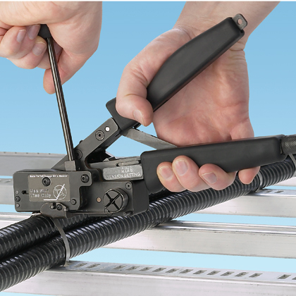
Retained Tension Tools feature a robust tie tensioning mechanism and a smooth cut-off to deliver improved durability and job-site safety compared to conventional gripper style tools. The ergonomic design promotes operator safety with increased productivity.

For more information on Retained Tension Ties and Tools, request Product Bulletin SA-SSCB16 through customer service (email: cs@panduit.com, phone: 800-777-3300) or view on the website (www.panduit.com).
About PANDUIT:
PANDUIT is a leading, world-class developer and provider of innovative networking and electrical solutions. For more than 50 years, PANDUIT has engineered and manufactured end-to-end solutions that assist our customers in the deployment of the latest technologies. Our global expertise and strong industry relationships make PANDUIT a valuable and trusted partner dedicated to delivering technology-driven solutions and unmatched service. Through our commitment to innovation, quality and service, PANDUIT creates competitive advantages to earn customer preference.

