Order Form

1

Customer Info

First Name

Distributor
Custom Padlocks [GPSL]
Date

Distributor Info

Last Name Company Phone/Fax Email
PO to Dist.
2
1
Choose Padlock Type
PSL-8 Safety Lockout

Distributor Contact Account # Phone/Fax
Email

PO to Panduit
Clear

PSL-6
Laminated Steel
PSL-7
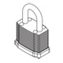
High Security
PSL-8
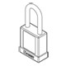
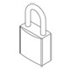
Safety Lockout
PSL-8-LB
Long Body
PSL-12
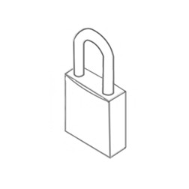
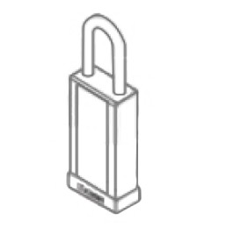
Compact Aluminum

Keying Options Identification Options
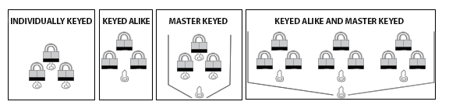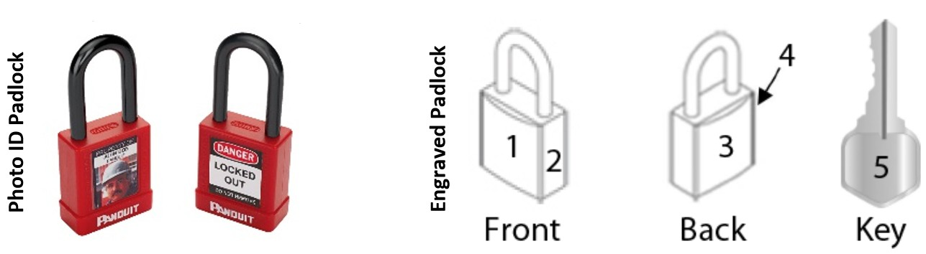

Choose Padlock Options
2
Quantity: Minimum of 12 per series

Keying | Identification | Shackle | Color | Part Number | Special Instructions | Qty
Keyed Alike | None |  | Red | GPSL-8KA |  | 12
 |  |  |  |  |  |  | Clear
 |  |  |  |  |  |  | Clear Clear Clear Clear
Total Pieces |  |  |  |  |  | 12
I acknowledge that the selections on GA2-0061 and/or GA2-0204 (as applicable) are as they should appear on the product.

3

Order Submission

To specify Engraving and Photo ID options, complete & attach the
GA2-0061 Custom Padlock Engraving Order Form
and/or
GA2-0204 Custom Padlock Photo ID Order Form
when you submit this form
cs@panduit.com 800-777-3300
708-532-1811

Save
Orders cannot be
returned or cancelled.
Distributors, please submit this form to Customer Service with your Purchase Order.
Email

Print

Click here to return to all custom order forms.

GA2-0060

Thank you for your order. We appreciate the opportunity to serve your identification needs. www. panduit. com

16 OCT 14

