Authorized Manufacturer: Atlona, Inc.
UK Declaration of Conformity
Model Number:
AT-HD420
Product Name:
HDMI to VGA/Component + Stereo Audio Format
Converter
70 Daggett Drive
San Jose, CA 95134
USA
(408) 962-0515
This product conforms with the provisions of the following EC directives, including all amendments, and with national legislation implementing these directives.
Regulations: | Electromagnetic Compatibility Regulations 2016  The Restriction of the Use of Certain Hazardous Substances in Electrical and Electronic Equipment Regulations 2012
The following harmonized standards were applied:
Standards: BS EN 55032:2015/AC:2016 Class A,
BS EN 55024:2010

This product carries the UKCA mark, which was affixed in 2021.
Authorized Signatory: 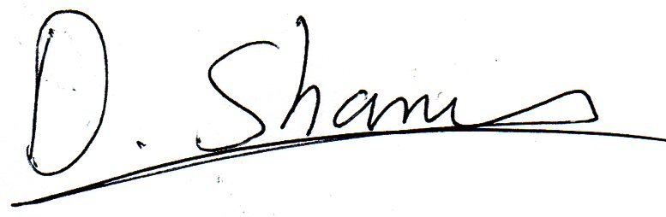______________________________________________ David Shamir, Vice President Product Management
Date:
Place: San Jose, CA, USA

