UK Declaration of Conformity

UK Declaration of Conformity
Model Number: | AT-UHD-SW-51

Product Name: | Atlona 5 X 1 HDMI Switcher

Authorized Manufacturer: | Atlona, Inc.  70 Daggett Drive San Jose, CA 95134 USA  (408) 962-0515

This product conforms with the provisions of the following UK regulations, including all amendments, and with national legislation implementing these regulations.

Regulations: | The Restriction of the Use of Certain Hazardous Substances in  Electrical and Electronic Equipment Regulations 2012  Electromagnetic Compatibility Regulations 2016

The following harmonized standards were applied:

Standards: | EN 55032:2015/AC:2016 Class B  EN 55024:2010

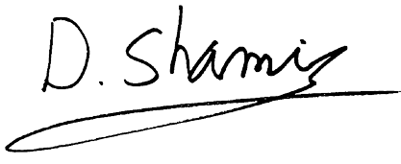
This product carries the UKCA mark, which was affixed in 2021.

Authorized Signatory: | David Shamir, Vice President Product Management

Date: | May 28, 2021

Place: | San Jose, CA, USA

