Authorized Manufacturer: Atlona, Inc.
UK Declaration of Conformity
Model Number:
AT-WAVE-101

Product Name:
Wireless Presentation and Collaboration System

70 Daggett Drive
San Jose, CA 95134
USA
(408) 962-0515
This product conforms with the provisions of the following EC directives, including all amendments, and with national legislation implementing these directives.
Regulations: | Electromagnetic Compatibility Regulations 2016  The Restriction of the Use of Certain Hazardous Substances in  Radio Equipment Regulations 2017
The following harmonized standards were applied:
Standards BS EN 55032:2015
BS EN 55024:2010
ETSI EN 301 489-1 V2.2.3: 2019-11
ETSI EN 301 489-17 V3.2.4: 2020-09

This product carries the UKCA mark, which was affixed in 2021.
Authorized Signatory: 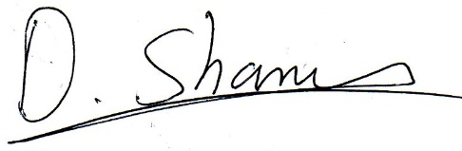______________________________________________ David Shamir, Vice President Product Management
Date:
Place: San Jose, CA, USA

