SECTION 27 11 26
Communications RACK MOUNTED POWER PROTECTION AND POWER STRIPS
Notes to the Specification Writer:
This Section has been written to cover most, but not all, project conditions that you will encounter. Depending on the project, you may need to add material, delete items, or modify what is currently written. Editing instructions are included throughout the document. (If this document is viewed or printed in color, these instructions appear in red italic text.)
Review this entire specification Section and edit it to meet the requirements of the specific project. Options or items where the specification writer’s input is needed are enclosed in <<karets>>.
Before publishing your final version of this specifications, remove all placeholders / instructions in red text.
- GENERAL
- SUMMARY

This Section includes:

Intelligent Power Distribution Units (PDUs)

Environmental Sensors

USB LED Light Strips

Cabinet Security Devices

Examine the contract documents in their entirety (including drawings and specification sections in the other divisions) for requirements or work which may affect work under this section, regardless of whether such requirements or work are specifically indicated in this section.

Although such work is not specifically mentioned herein or on the Drawings, the Contractor shall furnish and install all miscellaneous items, accessories, appurtenances, and devices incidental to or necessary for a sound, secure, and complete installation, without claim for additional payment.

The Contractor shall provide system testing and demonstration, system documentation, and instruction of Owner personnel, without claim for additional payment.

Errors or Omissions in Drawings or Documentation

If any errors or omissions appear in Drawings, Specifications, or other documents, the bidding Contractor shall notify the Engineer no later than ten (10) days prior to submitting the bid.

Should conflict occur in or between Drawings and Specifications, the bidding Contractor is deemed to have estimated the more expensive way of doing the work, unless the bidding Contractor has asked for and obtained written decision (addendum) before submission of the bid as to which method or materials will be required.

Related Sections:

Section 00 00 00 – Procurement and Contracting Requirements

Section 01 00 00 – General Requirements

Section 26 05 26 – Grounding and Bonding for Electrical System

Section 27 05 00 – Common Work Results for Communications

Section 27 05 26 – Grounding and Bonding for Communication Systems

Section 27 05 53 – Identification for Communication Systems

Section 27 11 16 – Communications Cabinets, Racks, Frames, and Enclosures

Definitions

ANSI – American Northern Standards Institute

AWG – American Wire Gauge

BICSI – Building Industry Consulting Service International

EIA – Electronics Industry Alliance

ETL – Intertek Certification Services

IEC – International Electrotechnical Commission

IEEE – Institute of Electrical and Electronic Engineers

ISO – International Standards Organization

NECA – National Electrical Contractors Association

NFPA – National Fire Protection Agency

NRTL – Nationally Recognized Testing Laboratory

PDU – Power Distribution Unit

TIA – Telecommunications Industry Association

UL – Underwriters Laboratory

Provide: Furnish, install, terminate, label, test and certify a complete operating cabling system.

Contract Documents (CD): Design drawings, specifications, sketches and schedules provided by the Engineer as they directly relate to this scope of work and this project.

Network Center/Main Distribution Frame (MDF) Areas: This technology space houses Layer 2/3 network switching gear and other main network distribution equipment and acts as the mid–connection point between the Core/Network and the TR/IDF/access zones for all connections.

Telecommunications Room (TR)/Intermediate Distribution Frame (IDF): is the location for the termination of backbone cables and for termination of horizontal cables, and for the interconnection of each. The space also hosts access–layer switches and user network connections within each floor.

Active Equipment: electronic equipment used to develop various WAN, LAN, and voice services, e.g., digital multiplexers, RS–232 controllers, Ethernet hubs, switches, routers, PBX, etc.

Bonding: permanent joining of metallic parts to form an electrically conductive path which will assure electrical continuity and the capacity to conduct safely any current likely to be imposed on it.

Cabinet: free standing, floor–mounted or wall–mounted modular enclosure designed to house and protect rack–mounted electronic equipment and passive terminations.

Grounding: a conducting connection to earth, or to some conducting body that serves in place of earth.

LAN: Local area network.

Mounting Frame: rectangular steel framework, which can be equipment rack or wall mounted to support wiring blocks, patch panels, and other communications equipment.

Passive Equipment: non–electronic hardware and apparatus, e.g., equipment racks, cable trays, electrical protection, patch panels, wiring blocks, fiber optic shelves, etc.

Protectors: electrical protection devices used to limit foreign voltages on metallic communications circuits.

Racks: An open, freestanding, floor–mounted structure, typically made of aluminum or steel, used to mount equipment; usually referred to as an equipment rack.

Work Area Subsystem: The connection between the telecommunications outlet and the station equipment in the work area is provided by the Work Area Subsystem. It consists of cords, adapters, and other transmission electronics.

Contractor – The successful bidder engaged to provide the work of this specification.

REFERENCES

Most recent editions and addenda of the following documents:

ANSI/TIA-568-D.0 Generic Telecommunications Cabling for Customer Premises, 2015.

ANSI/TIA – 568-D.1 Commercial Building Telecommunications Cabling Standard, 2015.

ANSI/NECA/BICSI 568-2006 – Standard for Installing Commercial Building.

ANSI/TIA-569-D Telecommunications Pathways and Spaces, 2015.

ANSI/TIA-942-A Telecommunications Infrastructure Standard for Data Centers, 2014.

E. ANSI/TIA – 606-B Administration Standard for Telecommunications Infrastructure, 2012.

TIA – 607-C Generic Telecommunications Bonding and Grounding (Earthing) For Customer Premises, 2015.

ANSI/NFPA 70 – National Electric Code, 2008, 2014.

2014/35/EU – Low Voltage Directive.

2014/30/EU – Electromagnetic Compatibility Directive.

2011/65/EU – Restriction of use of certain hazardous substances in electrical and electronic equipment directive (RoHS2).

EN 55032:2015 – Information technology equipment. Radio disturbance characteristics. Limits and method of measurement.

EN 55024:2010 – Information technology equipment. Immunity characteristics. Limits and methods of measurement.

EN 60950-1: 2006/A11:2009/A1:2010/A12:2011/A2:2013 – Information technology equipment. Safety. General requirement (Replaced by IEC 62368-1).

IEC 62368-1: Audio/video, information and communication technology equipment - Part 1: Safety requirements

EN 50600-2-2: Data Center Electrical Power Distribution.

Telecommunications Cabling. Telecommunications Distribution Methods Manual, most recent edition.

Information Transport Systems Installation Methods Manual (ITSIMM), most recent edition.

National Electric Codes (NEC) – all applicable.

OSHA Standards and Regulations – all applicable.

Local Codes and Standards – all applicable.

Local Authority Having Jurisdiction (AHJ).

Anywhere cabling standards conflict with one another or with electrical or safety codes, Contractor shall defer to the NEC and any applicable local codes or ordinances, or default to the most stringent requirements listed by either.

Any violations of applicable standards or codes committed by the Contractor shall be remedied at the Contractor’s expense.

SYSTEM DESCRIPTION

The Contractor will provide, install, and test a complete in rack and/or in cabinet power distribution unit (PDU), and if applicable, PDU connected environmental sensors and PDU connected Cabinet door access control system.

Typical Telecom Room (TR) or Equipment Room (ER)

A typical ER will consist of the following equipment:

One or more cabinets, floor-mounted open racks, wall-mounted racks, or enclosures, which shall have horizontal and vertical cable management and, when floor mounted racks are used, horizontal stabilization, which may be provided by the cable runway from the rack to the wall, though if this is insufficient, shall have supports fabricated by the Contractor.

A room-level or building-level Uninterruptible Power Supply (UPS) system.

A rack-mounted PDU.

A grounding and bonding system connected to the building’s main grounding electrode system.

SUBMITTALS

Engineer’s Review

The Engineer’s review of shop drawings or samples shall not relieve the Contractor of responsibility for any deviation from the contract documents.

With the shop drawings, the Contractor shall include an index sheet detailing all deviations from the contract documents, and will be held responsible for all deviations, unless the Contractor has received written approval from the Engineer for the specific deviation, separate from general shop drawing approval.

The Engineer’s review shall not relieve the Contractor from responsibility for errors or omissions in the shop drawings or samples.

General Component Data

For all products covered under this Section, the Contractor shall submit the following data for each component:

A Specification Section.

The Manufacturer’s name.

The Manufacturer’s model and part number.

QUALITY ASSURANCE

Standards for Materials and Equipment

The Contractor shall provide all materials, equipment, and installation in compliance with the latest applicable standards from ANSI, FCC, ASTM, EIA/TIA, IEEE, NEC, NFPA, NEMA, OSHA, REA, and UL.

Product Certifications: FCC Rules Part 15 – EMC Verification, Canadian ICES-003.

DELIVERY, STORAGE, AND HANDLING

To prevent damage, theft, soiling, and misalignment, protect equipment during transit, storage, and handling.

The contractor shall coordinate the secure storage of equipment and materials on site, or, if no on-site storage is available, shall provide their own secure storage at the Contractor’s expense.

Do not store equipment where conditions fall outside the manufacturer's recommendations for environmental conditions.

Do not install damaged equipment. Remove environmental conditions from the site and replace damaged equipment with new equipment.

If off-site storage of materials is necessary, this shall be at the Contractor’s expense.

COORDINATION

The Contractor shall coordinate with all other trades. The Contractor will submit a schedule for the installation within 10 days of contract award.

The schedule shall include delivery, installation, and testing for conformance to specific job completion dates.

At minimum, the schedule shall provide dates for the start of demolition, the completion of demolition, the installation start date, the completion of copper cabling, the completion of backbone cabling, the completion of testing and labeling, cutover, the completion of the final punch list, final inspection, and acceptance.

Meeting Attendance and Schedule Adherence

The Contractor must attend all project-related meetings and adhere to schedule set by the Project Manager.

Final Inspection

The Contractor is required to notify the Engineer of a proposed appointment for Final Inspection at least 72 hours before the appointment.

Within five working days after the final inspection, the Contractor shall send final project documentation and warranty information to the Owner and Engineer. The final project documentation shall include, but may not be limited to:

As-Built Drawings, in an AutoCAD format, with legible outlet address and cable paths.

Warranty paperwork.

A copy of the Final Inspection and Acceptance Signoff Sheet.

Photos of each ER and TR.

PROJECT CONDITIONS

Project Environmental Requirements

Hazardous Materials Prohibition

The Contractor shall ensure that all materials used in the project are asbestos-free, unless specifically authorized in writing by the Owner.

Existing Conditions

Verify that all conditions on the project site are acceptable for the Work specified in this Section. Prior to bid opening, notify the Consulting Engineer, in writing, of any discrepancies, conflicts, or omissions. Otherwise, correct these issues at no additional cost to the Owner.

Continue to monitor the project site. If conditions develop that require a variance from the Specifications or Drawings, then immediately notify the Owner in writing. Otherwise, make recommendations, submit drawings showing how the Work may be installed, and, upon approval, proceed with the necessary changes without additional cost to the Owner.

Record Drawings

Keep a complete set of all telecommunications drawings in the job site office for demonstration of the actual installation work specified in this Section.

Use this set of drawings for no other purpose.

Where any material, equipment, or system components are installed differently than what is shown on the drawings, indicate the differences clearly and neatly using ink or indelible pencil.

Upon completion of the project, submit the record set of drawings.

USE OF THE SITE

Where the Owner deems it necessary to place restrictions, use the site as directed by the Owner.

When proceeding with the work, do not interfere with the ordinary use of streets, aisles, passages, exits, or operations of the Owner. During the day, set up cones and barriers in hallways and walkways. Do not string cable down the hallways during normal hours.

Request a hazardous materials worksheet that identifies potentially-hazardous locations. Do not proceed with any work in locations where hazardous materials are known to be. Obtain instructions from the Contractor’s Project Manager on and when to work in these areas.

Multiple times each day, each contractor shall remove all trash and debris from the site. Before leaving the room each day:

The Contractor shall replace all ceiling tiles that they have removed.

The Contractor shall place all furniture and equipment that they have moved back into its original location.

The Contractor shall return any equipment that they have disconnected to working order.

The Contractor’s Job Foreman shall inspect all work locations to ensure that the rooms are clean and that all of the tasks described above have been done.

It is recommended that the Contractor inspect the site and take pictures to document the condition of the ceilings and walls.

CONTINUITY OF SERVICES

Take no action that will interfere with or interrupt existing building services, unless previous arrangements have been made with the Owner's representative. Arrange all work to minimize shutdown time.

The Owner's personnel shall perform shutdown of operating systems. When shutdown of systems is required, the Contractor shall give three (3) days advance notice.

Should building services be inadvertently interrupted:

The Job Foreman shall immediately notify the Project Manager of the accidental disruption of services, the remedy, and how long it will take to restore services.

The Contractor shall immediately furnish the labor, including overtime, the material, and the equipment necessary to promptly restore the interrupted service at no cost to the Owner.

WARRANTY

Refer to Section 27 05 00.

PRODUCTS

GENERAL

Refer to Section 27 05 00 for General Requirements

All materials and products shall be:

Appropriate for the intended use.

Recognized as such by a Nationally Recognized Testing Laboratory (NRTL) such as Underwriters Laboratories (UL), ETL SEMCO (ETL), the Canadian Standards Association (CSA) or the American National Standards Institute (ANSI).

Permitted by the Authority Having Jurisdiction (AHJ).

All products shall be new, of the latest version at time of bid, and brought to the job site in original manufacturer's packaging. Used equipment and damaged material will be rejected.

Any modifications to equipment to suit the intent of the specifications shall be performed in accordance with these requirements.

Take care during installation to prevent scratches, dents, chips, etc. Equipment with significant or disfiguring cosmetic flaws will be rejected.

All components will be approved by the Engineer and shall have the most aesthetic value possible while maintaining specified functionality. Hardware shall:

Be in compliance with the Construction documents.

Have fit and finish compatible with the existing surrounding structure.

Be unobtrusive.

Provide the required functionality.

All work area termination hardware, including mounting boxes, faceplates, and outlets, shall match the existing wall surface color as closely as possible.

All copper and fiber products shall be from a single manufacturer so that a single performance warranty covers all applications on vertical and horizontal links.

Fabricate custom-made equipment with careful consideration given to aesthetic, technical, and functional aspects of the equipment and its installation.

Provide products that are suitable for the intended use, including, but not limited to environmental, regulatory, and electrical factors.

SUBSTITUTION POLICY

Refer to Section 27 05 00

This is a performance-based specification developed from the experience of <<ClientName>> IT in providing exceptional solutions for all our facilities and departments. As such, substitution of specified products or systems is not allowed.

Contractor shall assume all costs for removal and replacement of any product installed in substitution of those specified. Such costs shall include but not be limited to labor, materials as well as any penalties, fees or costs incurred for late completion.

POWER DISTRIBUTION UNITS (PDUs)

Subject to compliance with requirements, provide appropriate PDU receptacle, input current, phases, outlet counts needed with the following features:

Withstand 60°C (140°F) operating temperature at full electrical load.

Support high density to minimize space and maximize airflow in a cabinet with a profile of 2x2x69 inches to be supported for 42 RU or larger cabinets.

Support a narrow profile (nominal of 2-inch width) for single row of outlets.

Support a wide range of power densities from 1.4 kVA to 44.4 kVA.

Network control and display on each PDU must be Hot-Swappable. Removing the controller from the PDU chassis shall not disrupt power at the outlet.

Network control module and display units should be field rotatable by 180 degrees allowing for the same part number to be used for either overhead or underfloor power applications.

Network control module must contain power share feature to allow for a daisy chained PDU control module to remain ‘on’ during a power outage of 1 of the 2 power feeds.

Bright OLED display and high contrast ratio with power-save mode.

Redundant Network Access (RNA) for Network redundancy for up to 2 PDUs daisy chained together.

Power outlet switching and critical functionality of PDU must be conducted via administrator privileges.

Secure network monitoring must support SNMP v3 to avoid intrusion.

Rack PDUs must support latest security scans and pass the stringent security requirements of HPE Web Inspect and DDI Frontline.

The PDU natively must support variety of sensors and access control solutions via the same PDU unit and no external gateway device. The sensors shall be self-identifying to the PDU to optimize deployment.

Support colored PDU chassis to delineate between power feeds in redundant input power applications.

Support color-coded PDU outlets to identify each of the 3 phases with matching color coded breakers.

Support 1Gbit/s network connection and allows up to 4 PDUs to being daisy chained to conserve IP addresses.

The PDU must include threaded inserts on both sides and the back of the PDU chassis to allow for moving the mounting buttons to allow for flexibility in mounting options.

Web GUI of the PDU must adapt to the viewing screen of the user device for an optimal user interface on KVM, Laptops, Smartphones and/or Tablets.

Locking IEC outlets are compatible with secure W and V locking power cords with additional support via standard cable ties.

Support minimum 3-Year standard and 6-Year extended warranty by manufacturer.

Scalability in terms of managing device with local web server to a (on prem or cloud based) DCIM software suite for energy and power monitoring over SNMP.

Support firmware upgrades or configuration replication over the USB provisioning port without compromising non-compliant devices over the network. USB provisioning port must be able to being disabled with Command Line Interface (CLI) command for intrusion protection.

Energy utilization monitoring accurate to +/- 1% for billing grade accuracy meeting IEC specifications. The metrics must also cover V, A, VA, W, KWh, and PF readings.

Support high reliability hydraulic magnetic circuit breakers stable at 60°C (140°F) operating temperature.

Support a full breadth of offering for a flexible application, including non-monitored, aggregate monitoring, switched per outlet with aggregate monitoring, monitored per outlet with aggregate monitoring, outlet switching and outlet monitoring with aggregate monitoring options.

Meet global power compliance standards: Certified through Nationally Recognized Testing Laboratories (NRTL) and approved for specific countries.

Support branch circuit monitoring and load balancing of each circuit.

Support cable retention with either a dual locking power cord or with an accessory (e.g. Cable ties).

Display all three phases at once on OLED display for each in manual data collection.

The PDU vendor must be able to provide digital environmental sensors to simplify the deployment process.

Types of available PDUs

Subject to compliance with requirements, provide for non-Monitored PDU (Basic).

Power Distribution Units must distribute power to all outlets.

Subject to compliance with requirements, provide Aggregate Monitored PDU (Monitored Input).

Power Distribution Units must support total power monitoring of a PDU and report data on aggregate power consumption.

Subject to compliance with requirements, provide Aggregate Monitored and per Outlet Switched PDU (Monitored Switched).

Power Distribution Units must support total power monitoring of a PDU and report data on aggregate power consumption. The outlets can be powered on or off remotely. It can also provide sequential power on or off functionality.

Subject to compliance with requirements, provide Per Outlet Monitored PDU (Monitored Outlet).

Power Distribution Units must support per outlet power monitoring of a PDU and report data on aggregate power consumption.

Subject to compliance with requirements, provide Per Outlet Monitored PDU and Per Outlet Switched (Monitored and Switched per Outlet).

Power Distribution Units must support per outlet power monitoring of a PDU and report data on aggregate power consumption and outlets be powered on or off remotely. PDU can also provide sequential power on or off functionality.

<<ClientName>> approved Power Distribution Units (PDU) part numbers in table below. The part numbers and sizes listed are a small subset of the number available. For additional information, contact Panduit customer service or refer to the current parts catalog.
Part Number | Description
Basic PDU
P12B47M | G5 Basic PDU - 30A, 208V horizontal single phase PDU has (12) C13 receptacles, a 10' (3m) power cord with a NEMA L6-30P plug, and measures 1.7"H x 17.5"W x 7.8"D (43.2mm x 444.5mm x 198.1mm). UL Listed
P20B16M | G5 Basic PDU - 30A, 208V vertical single phase PDU has (20) C13 receptacles, a 10' (3m) power cord with a NEMA L6-30P plug, and measures 32.2"L x 2.0"W x 2.1"D (817.9mm x 50.8mm x 53.3mm). UL Listed
P42B23M | G5 Basic PDU - 30A, 208V vertical 3 Phase Delta PDU has (36) C13 and (6) C19 receptacles, a 10' (3m) power cord with a NEMA L15-30P plug, and measures 68.9"L x 2.0"W x 2.1"D (1750.1mm x 50.8mm x 53.3mm). UL Listed
Monitored Input – MI Series
P24D07M | Panduit® G5 Monitored Input PDU, 30A, 1Phase, 230 V, (20)C13, (4)C19, NEMA L6-30P Input Plug with a 10' (3m) power cord
P38D25M | Panduit® G5 Monitored Input PDU, 30A, 1Phase, 208 V, (32)C13, (6)C19, NEMA L6-30P Input Plug with a 10' (3m) power cord
P36D08M | Panduit® G5 Monitored Input PDU, 30A, 3Phase, 208 V, (30)C13, (6)C19, NEMA L15-30P Input Plug with a 10' (3m) power cord
P24D34M | Panduit® G5 Monitored Input PDU, 60A, 3Phase, 208 V, (12)C13, (12)C19, IEC 60309 3P+E 9h 60A (IP44) Input Plug with a 10' (3m) power cord
P36D30M | The G5 Monitored Input PDU features (24) C13 and (12) C19 outlets. It is a 50 amp, 208 V, three phase PDU with a CS8365C input plug and a 10 foot (3m) power cord.
P36D31M | The G5 Monitored Input PDU features (24) C13 and (12) C19 outlets. It is a 60 amp, 208 V, three phase PDU with an IEC 60309 3P+E 9h 60A (IP44) input plug and a 10 foot (3m) power cord.
P48D20M | The G5 Monitored Input PDU features (24)C13/C15, (24)C13/15/C19/C21 outlets. This PDU is designed with combination outlets which allows the receptacle to be used as an C13/C15/C19 or C21 outlet. It is a Dual Rated 30/32 amp 415V three phase PDU with an IEC 60309 3P+N+E 6h 30A/32A (IP44) input plug and a 10 foot (3m) power cord. The PDU is black.
P48D21M | The G5 Monitored Input PDU features (24)C13/C15, (24)C13/15/C19/C21 outlets. This PDU is designed with combination outlets which allows the receptacle to be used as an C13/C15/C19 or C21 outlet. It is a 30 amp 208V three phase PDU with an NEMA L21-30P input plug and a 10 foot (3m) power cord. The PDU is black.
P48D22M | The G5 Monitored Input PDU features (24)C13/C15, (24)C13/15/C19/C21 outlets. This PDU is designed with combination outlets which allows the receptacle to be used as an C13/C15/C19 or C21 outlet. It is a 30 amp 208V three phase PDU with an L15-30P input plug and a 10 foot (3m) power cord. The PDU is black.
P42D20M | The G5 Monitored Input PDU features (21)C13/C15, (21)C13/C15/C19/C21 outlets. This PDU is designed with combination outlets which allows the receptacle to be used as an C13/C15/C19 or C21 outlet. It is a 60 amp 208V three phase PDU with an IEC 60309 3P+E 9h 60A (IP44) input plug and a 10 foot (3m) power cord. The PDU is black.
P48D23M | The G5 Monitored Input PDU features (24)C13/C15, (24)C13/15/C19/C21 outlets. This PDU is designed with combination outlets which allows the receptacle to be used as an C13/C15/C19 or C21 outlet. It is a Dual Rated 20/16 amp 415V three phase PDU with an IEC 60309 3P+N+E 6h 20A/16A (IP44) input plug and a 10 foot (3m) power cord. The PDU is black.
P42D21M | The G5 Monitored Input PDU features (21)C13/C15, (21)C13/C15/C19/C21 outlets. This PDU is designed with combination outlets which allows the receptacle to be used as an C13/C15/C19 or C21 outlet. It is a Dual Rated 60/63 amp 415V three phase PDU with an IEC 60309 3P+N+E 6h 60/63A (IP44) input plug and a 10 foot (3m) power cord. The PDU is black.
P42D22M | The G5 Monitored Input PDU features (21)C13/C15, (21)C13/C15/C19/C21 outlets. This PDU is designed with combination outlets which allows the receptacle to be used as an C13/C15/C19 or C21 outlet. It is a 50 amp 208V three phase PDU with an CS8365 input plug and a 10 foot (3m) power cord. The PDU is black.
Monitored Switched – MS Series
P24E28M | Panduit® G5 Monitored Switched PDU, 30A, 1Phase, 230 V, (20)C13, (4)C19, NEMA L6-30P Input Plug with a 10' (3m) power cord
P36E33M | Panduit® G5 Monitored Switched PDU, 30A, 1Phase, 230 V, (30)C13, (6)C19, NEMA L6-30P Input Plug with a 10' (3m) power cord
P36E34M | Panduit® G5 Monitored Switched PDU, 30A, 3Phase, 208 V, (30)C13, (6)C19, NEMA L15-30P Input Plug with a 10' (3m) power cord
P24E32M | Panduit® G5 Monitored Switched PDU, 60A, 3Phase, 208 V, (12)C13, (12)C19, IEC 60309 3P+E 9h 60A (IP44) Input Plug with a 10' (3m) power cord
P48E20M | The G5 Monitored Switched PDU features (24)C13/C15, (24)C13/15/C19/C21 outlets. This PDU is designed with combination outlets which allows the receptacle to be used as an C13/C15/C19 or C21 outlet. It is a Dual Rated 30/32 amp 415V three phase PDU with an IEC 60309 3P+N+E 6h 30A/32A (IP44) input plug and a 10 foot (3m) power cord. The PDU is black.
P48E21M | The G5 Monitored Switched PDU features (24)C13/C15, (24)C13/15/C19/C21 outlets. This PDU is designed with combination outlets which allows the receptacle to be used as an C13/C15/C19 or C21 outlet. It is a 30 amp 208V three phase PDU with an NEMA L21-30P input plug and a 10 foot (3m) power cord. The PDU is black.
P48E22M | The G5 Monitored Switched PDU features (24)C13/C15, (24)C13/15/C19/C21 outlets. This PDU is designed with combination outlets which allows the receptacle to be used as an C13/C15/C19 or C21 outlet. It is a 30 amp 208V three phase PDU with an L15-30P input plug and a 10 foot (3m) power cord. The PDU is black.
P48E24M | The G5 Monitored Switched PDU features (24)C13/C15, (24)C13/15/C19/C21 outlets. This PDU is designed with combination outlets which allows the receptacle to be used as an C13/C15/C19 or C21 outlet. It is a 60 amp 208V three phase PDU with an IEC 60309 3P+E 9h 60A (IP44) input plug and a 10 foot (3m) power cord. The PDU is black.
P48E23M | The G5 Monitored Switched PDU features (24)C13/C15, (24)C13/15/C19/C21 outlets. This PDU is designed with combination outlets which allows the receptacle to be used as an C13/C15/C19 or C21 outlet. It is a Dual Rated 20/16 amp 415V three phase PDU with an IEC 60309 3P+N+E 6h 20A/16A (IP44) input plug and a 10 foot (3m) power cord. The PDU is black.
P48E25M | The G5 Monitored Switched PDU features (24)C13/C15, (24)C13/15/C19/C21 outlets. This PDU is designed with combination outlets which allows the receptacle to be used as an C13/C15/C19 or C21 outlet. It is a Dual Rated 60/63 amp 415V three phase PDU with an IEC 60309 3P+N+E 6h 60/63A (IP44) input plug and a 10 foot (3m) power cord. The PDU is black.
P48E26M | The G5 Monitored Switched PDU features (24)C13/C15, (24)C13/15/C19/C21 outlets. This PDU is designed with combination outlets which allows the receptacle to be used as an C13/C15/C19 or C21 outlet. It is a 50 amp 208V three phase PDU with an CS8365 input plug and a 10 foot (3m) power cord. The PDU is black.
Monitored Per Outlet – MPO Series
P36F15M | Panduit® G5 Monitored Per Outlet PDU, 30A, 1Phase, 230 V, (30)C13, (6)C19, NEMA L6-30P Input Plug with a 10' (3m) power cord
P24F02M | Panduit® G5 Monitored Per Outlet PDU, 30A, 3Phase, 208 V, (18)C13, (6)C19, NEMA L15-30P Input Plug with a 10' (3m) power cord
P24F05M | Panduit® G5 Monitored Per Outlet PDU, 60A, 3Phase, 208 V, (12)C13, (12)C19, IEC 60309 3P+E 9h 60A (IP44) Input Plug with a 10' (3m) power cord
Monitored Switched Per Outlet – MSPO Series
P36G18M | Panduit® G5 Monitored & Switched per Outlet PDU, 30A, 1Phase, 230 V, (30)C13, (6)C19, NEMA L6-30P Input Plug with a 10' (3m) power cord
P36G22M | Panduit® G5 Monitored & Switched per Outlet PDU, 30A, 3Phase, 208 V, (30)C13, (6)C19, NEMA L15-30P Input Plug with a 10' (3m) power cord
P24G05M | Panduit® G5 Monitored & Switched per Outlet PDU, 60A, 3Phase, 208 V, (12)C13, (12)C19, IEC 60309 3P+E 9h 60A (IP44) Input Plug with a 10' (3m) power cord
P36G30M | The G5 Monitored & Switched per Outlet PDU features (24) C13 and (12) C19 outlets. It is a 50 amp, 208 V, 3 phase PDU with a CS8365C input plug and a 10 foot (3m) power cord.
P36G31M | The G5 Monitored & Switched per Outlet PDU features (24) C13 and (12) C19 outlets. It is a 60 amp, 208 V, 3 phase PDU with a IEC 60309 3P+E 9h (IP44) input plug and a 10 foot (3m) power cord.
P36G32M | The G5 Monitored & Switched per Outlet PDU features (24) C13 and (12) C19 outlets. It is a 20A (NA)/ 16A (EU), 415 V, 3 phase PDU with a IEC 60309 3P+E 6h (IP44) input plug and a 10 foot (3m) power cord.
P36G33M | The G5 Monitored & Switched per Outlet PDU features (24) C13 and (12) C19 outlets. It is a 30A (NA)/ 32A (EU), 415 V, 3 phase PDU with a IEC 60309 3P+E 6h (IP44) input plug and a 10 foot (3m) power cord.
P36G34M | The G5 Monitored & Switched per Outlet PDU features (24) C13 and (12) C19 outlets. It is a 60A (NA), 415 V, 3 phase PDU with a IEC 60309 3P+E 6h (IP44) input plug and a 10 foot (3m) power cord.
P48G30M | The G5 Monitored & Switched per Outlet PDU features (24)C13/C15, (24)C13/15/C19/C21 outlets. This PDU is designed with combination outlets which allows the receptacle to be used as an C13/C15/C19 or C21 outlet. It is a Dual Rated 30/32 amp 415V three phase PDU with an IEC 60309 3P+N+E 6h 30A/32A (IP44) input plug and a 10 foot (3m) power cord. The PDU is black.
P48G31M | The G5 Monitored & Switched per Outlet PDU features (24)C13/C15, (24)C13/15/C19/C21 outlets. This PDU is designed with combination outlets which allows the receptacle to be used as an C13/C15/C19 or C21 outlet. It is a 30 amp 208V three phase PDU with an NEMA L21-30P input plug and a 10 foot (3m) power cord. The PDU is black.
P48G32M | The G5 Monitored & Switched per Outlet PDU features (24)C13/C15, (24)C13/15/C19/C21 outlets. This PDU is designed with combination outlets which allows the receptacle to be used as an C13/C15/C19 or C21 outlet. It is a 30 amp 208V three phase PDU with an L15-30P input plug and a 10 foot (3m) power cord. The PDU is black.
P42G20M | The G5 Monitored & Switched per Outlet PDU features (21)C13/C15, (21)C13/C15/C19/C21 outlets. This PDU is designed with combination outlets which allows the receptacle to be used as an C13/C15/C19 or C21 outlet. It is a 60 amp 208V three phase PDU with an IEC 60309 3P+E 9h 60A (IP44) input plug and a 10 foot (3m) power cord. The PDU is black.
P48G33M | The G5 Monitored & Switched per Outlet PDU features (24)C13/C15, (24)C13/15/C19/C21 outlets. This PDU is designed with combination outlets which allows the receptacle to be used as an C13/C15/C19 or C21 outlet. It is a Dual Rated 20/16 amp 415V three phase PDU with an IEC 60309 3P+N+E 6h 20A/16A (IP44) input plug and a 10 foot (3m) power cord. The PDU is black.
P42G21M | The G5 Monitored & Switched per Outlet PDU features (21)C13/C15, (21)C13/C15/C19/C21 outlets. This PDU is designed with combination outlets which allows the receptacle to be used as an C13/C15/C19 or C21 outlet. It is a Dual Rated 60/63 amp 415V three phase PDU with an IEC 60309 3P+N+E 6h 60/63A (IP44) input plug and a 10 foot (3m) power cord. The PDU is black.
P42G22M | The G5 Monitored & Switched per Outlet PDU features (21)C13/C15, (21)C13/C15/C19/C21 outlets. This PDU is designed with combination outlets which allows the receptacle to be used as an C13/C15/C19 or C21 outlet. It is a 50 amp 208V three phase PDU with an CS8365 input plug and a 10 foot (3m) power cord. The PDU is black.

PDU Attached Environmental SensorS

Subject to compliance with requirements, provide Temperature and Humidity Sensors.

Include an embedded microchip that converts analog signals to digital format before data travels to the PDU. Used to add environmental monitoring to any PDU.

Quick Disconnect Coupler and Ethernet cable.

The temperature and humidity sensors should comply with the following specifications:

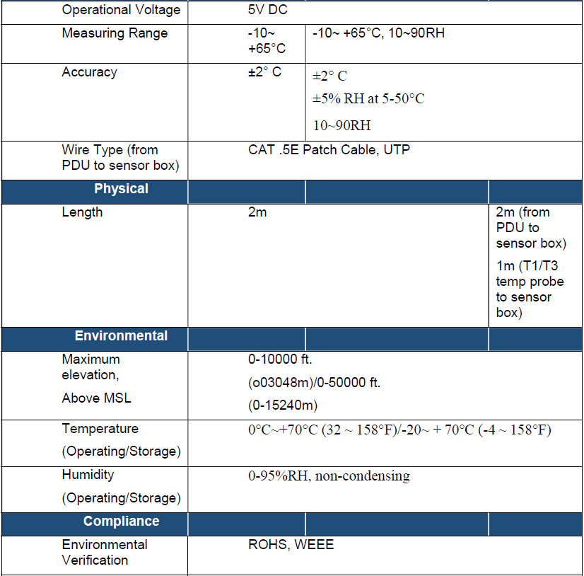

<<ClientName>> approved Manufacturer:

Panduit

<<ClientName>> approved Sensor part numbers in table below. For additional information, contact Panduit customer service or refer to the current parts catalog.
Part Number | Description
EA001 | ENV Temp Sensor
EB001 | ENV Temp, Humidity Sensor
EC001 | ENV 3-Temp, 1-Humidity Sensor

Subject to compliance with requirements, provide an environmental sensor hub.

Allow for 3 additional sensor ports to be added to iPDU, with the ability to install 2 Sensor Hubs with a PDU allowing for 8 sensor measurements.

Environmental sensors should contain an embedded microchip that converts analog signals to digital format before data travels to the PDU.

The Sensor Hub should comply with the following specifications:

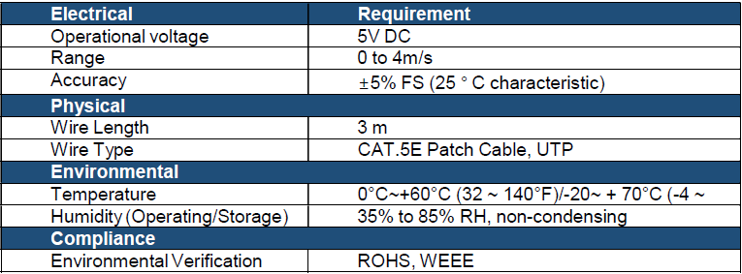

<<ClientName>> approved Manufacturer:

Panduit

<<ClientName>> approved Sensor Hub part numbers in table below. For additional information, contact Panduit customer service or refer to the current parts catalog.
Part Number | Description
EF001 | G5 Sensor Hub. The hub allows for 3 additional sensor ports. The hub measures 3.3 x 1.3 x 1.06 inches (85 x 32 x 27 mm)

Subject to compliance with requirements, provide a Rope Fluid Leak Sensor

Direct connection to a PDU.

Used to provide early detection of fluid in a data center or network closet along the entire length of the sensor cable.

The Rope Fluid Leak Sensor should comply with the following specifications:

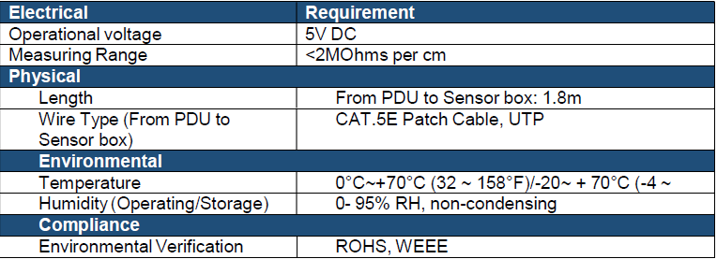

<<ClientName>> approved Manufacturer:

Panduit

<<ClientName>> approved Water Rope Sensor part numbers in table below. For additional information, contact Panduit customer service or refer to the current parts catalog.
Part Number | Description
ED001 | G5 Water Rope Sensor. From PDU to Sensor box: 5.9' (1.8m) cable. The Rope Fluid Leak Sensor Cable measures 19.7' (6m). The sensor measures 2.36 x 2.36 x 0.86 inches (60 x 60 x 22mm)

Subject to compliance with requirements, provide a Rope Fluid Leak Sensor Extension.

An extension to lengthen the detection zone of Rope Fluid Leak sensor.

The ability to connect up to 5 Rope Fluid Leak Sensor Extensions.

The Rope Fluid Leak Sensor Extension should comply with the following specifications:

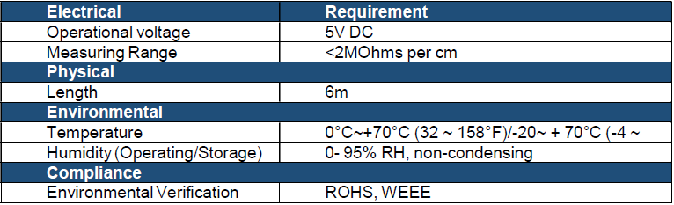

<<ClientName>> approved Manufacturer:

Panduit

<<ClientName>> approved Water Rope Extension part numbers in table below. For additional information, contact Panduit customer service or refer to the current parts catalog.
Part Number | Description
EG001 | G5 Water Rope Extension. Extension Cable measures 19.7' (6m)

Subject to compliance with requirements, provide a Spot Fluid Leak Sensor

Direct connection to a PDU.

Reliably monitor a remote location for the presence of water or any other conductive liquid.

Ability to extend (up to 30.5 m) using a standard RJ-45 coupling.

The Spot Fluid Leak Sensor should comply with the following specifications:

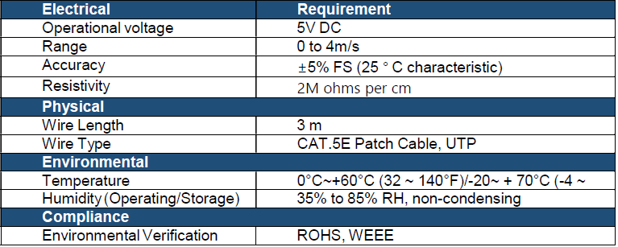

<<ClientName>> approved Manufacturer:

Panduit

<<ClientName>> approved Water Spot Sensor part numbers in table below. For additional information, contact Panduit customer service or refer to the current parts catalog.
Part Number | Description
EE001 | G5 Water Spot Sensor. From PDU to Sensor box: 16.4' (5m) cable. The sensor measures 2.36 x 2.36 x 0.86 inches (60 x 60 x 22mm)

Subject to compliance with requirements, provide a Dry Contact Cable

Monitor conditions such as moisture, motion, door status, and access through external dry contact sensors.

Ability to extend (up to 30.5 m) using a standard RJ45 coupling.

The Dry Contact Cable should comply with the following specifications:

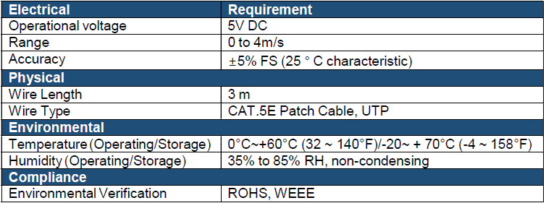

<<ClientName>> approved Manufacturer:

Panduit

<<ClientName>> approved Dry Contact Sensor part numbers in table below. For additional information, contact Panduit customer service or refer to the current parts catalog.
Part Number | Description
ACC01 | G5 Dry Contact Input. Length of cable from RJ45 connector to Sensor 5.9' (1.8m). Length of cable from sensor to Dry Contact Switch 5.9' (1.8m). Sensors measures 1.23 x 0.70 x 0.40 inches (44 x 21 x 11 mm). Switch not included.

Subject to compliance with requirements, provide a Door Switch SensoR

Direct connection to a PDU.

Send an alarm or notification signal when the door on which it is installed had been opened more than 10mm.

The Door Switch Sensor should comply with the following specifications:

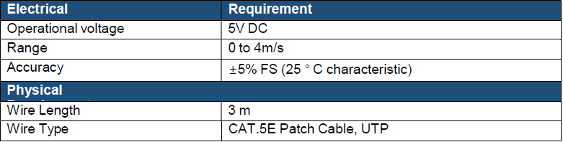

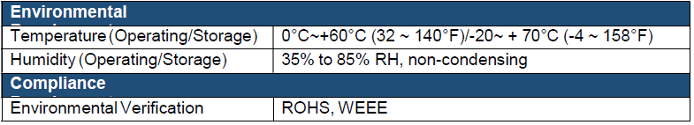

<<ClientName>> approved Manufacturer:

Panduit

<<ClientName>> approved Magnetic Door Sensor part numbers in table below. For additional information, contact Panduit customer service or refer to the current parts catalog.
Part Number | Description
ACA01 | G5 Magnetic Door Sensor 2 Piece. From PDU to Sensor box: 6.6' (2m) cable. From Magnetic Switch to Sensor Box 3.3' (1m). The sensor measures 1.73 x 0.83 x 0.43 inches (44 x 21 x 11 mm)

Subject to compliance with requirements, provide PDU Integrated Cabinet USB Light Strip

Connect to a PDU and light up when the door on which it is installed is opened more than 10mm.

The USB LED Light Strip should comply with the following specifications:

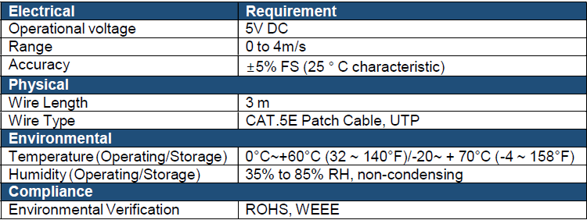

<<ClientName>> approved Manufacturer:

Panduit

<<ClientName>> approved USB Light Strip part numbers in table below. For additional information, contact Panduit customer service or refer to the current parts catalog.

Part Number | Description
ACD01 | G5 LED USB Light Strip. Length of cable from USB connector to LED Rack Light is 5' (1.5m). LED Light Strip Measures 15 x 1 x 0.5 inches (382 x 25 x 12 mm). From PDU to Sensor box: 6.6' (2m) cable. From Magnetic Switch to Sensor Box 3.3' (1m). The sensor measures 1.73 x 0.83 x 0.43 inches (44 x 21 x 11 mm)

Subject to compliance with requirements, provide Cabinet Security Electronic Locking Swing Handles, HID Reader, and Keypad Reader

The Electronic Locking Swing handle, the HID reader, and the keypad should be connected to the Rack PDU to control the cabinet doors (front & rear) access.

The electronic locking swing handle should have the following features and benefits:

It should feature an out-of-band security topology with the Rack PDU being the aggregation point for electronic rack access.

It should include a beacon function which can be remotely accessed to help locate the cabinet.

The beacon should also be integrated with the Rack PDU and automatically change colors reporting any alarms being sensed by the Rack PDU.

The keypad version of the electronic locking swing handle must feature dual authentication leveraging an RFID card swipe plus keypad pin code.

It should include integrated sensors for lock and latch status, monitoring and alarm functions.

It should have efficient gear motor design for low power consumption.

It should grant momentary or continuous lock actuation with integrated manual override lock.

It should be opened using a HID reader or Keypad.

It should be configured via the management platform and monitored via the management platform or the DCIM software.

<<ClientName>> approved Manufacturer:

Panduit

<<ClientName>> approved Cabinet Security Electronic Locking Swing Handles, HID Reader, and Keypad Reader part numbers in table below. For additional information, contact Panduit customer service or refer to the current parts catalog.
Part Number | Description
ACF05 | Security Handle with Dual Frequency (125 kHz and 13.56 MHz) Card Reader and integral humidity sensor.
ACF06 | Security Handle with Dual Frequency (125 kHz and 13.56 MHz) Card Reader, integral humidity sensor, and keypad for dual authentication.
ACF20 | Security Handle to Panduit G5 iPDU Harness (JST to RJ45 Male).
ACF10 | Security Handle Temperature and Door Sensor. Sensors only work with ACF05 and ACF06.
ACF11 | Security Handle (3) Temperature and Door Sensor. Sensors only work with ACF05 and ACF06
CRD-02-10PK | Security Handle HID Cards 125 kHz come in a pack of 10 cards.
CRD-03-10PK | Security Handle HID Cards 13.56 MHz come in a pack of 10 cards.

EXECUTION

GENERAL

Furnish any special installation equipment or tools necessary to properly complete the installation.

Failure to follow the appropriate guidelines may require the installer to provide additional material and labor required to properly rectify the situation.

Vertical Mounted PDUs

PDUs must be mountable with tool less mounting design to avoid compliance and security issues.

Horizontal/Vertical Mounted PDUs

PDUs must be available in 1RU and 2RU designs and most mount on standard EIA rails.

Must not exceed depth of 2.0in (50.8mm) for non-monitored models and 10.6in (269.75mm) for monitored models.

Allow for a vertically mount installation with tool less installation.

Support at a minimum of 6 outlets for 1RU models and 16 outlets for 2RU models.

SYSTEM ADMINISTRATION

Identify each location with a unique alphanumeric identifier.

Supply all records in compliance with ANSI/TIA 606.

IDENTIFICATION

Before installing PDUs, confirm all specific labeling requirements with the Owner or the Owner’s Engineer.

FIELD QUALITY CONTROL

General Testing

Refer to Section 27 05 00 for complete testing specifications.
END OF SECTION 27 11 26

