SECTION 27 05 53
Identification for communication systems

Notes to the Specification Writer:
Notes to the Specification Writer:
This Section has been written to cover most, but not all, project conditions that you will encounter. Depending on the project, you may need to add material, delete items, or modify what is currently written. Editing instructions are included throughout the document. (If this document is viewed or printed in color, these instructions appear in red italic text.)
Review this entire specification Section and edit it to meet the requirements of the specific project. Options or items where the specification writer’s input is needed are enclosed in <<karets>>.
Before publishing your final version of this specifications, remove all placeholders / instructions in red text.
- GENERAL

SUMMARY

This Section includes:

The supply, delivery, supervision, coordination, and installation of equipment items specified herein and shown on the Drawings.

The documentation and instruction for completing the Identification for Communication Systems.

Examine the contract documents in their entirety (including drawings and specification sections in the other divisions) for requirements or work which may affect work under this section, regardless of whether such requirements or work are specifically indicated in this section.

Contractor Shall Provide and Install

Although such work is not specifically mentioned herein or on the Drawings, the Contractor shall furnish and install all miscellaneous items, accessories, appurtenances, and devices incidental to or necessary for a sound, secure, and complete installation, without claim for additional payment.

Errors or Omissions in Drawings or Documentation

If any errors or omissions appear in Drawings, Specifications, or other documents, the bidding Contractor shall notify the Engineer no later than ten (10) days prior to submitting the bid.

Should conflict occur in or between Drawings and Specifications, the bidding Contractor is deemed to have estimated the more expensive way of doing the work, unless the bidding Contractor has asked for and obtained written decision (addendum) before submission of the bid as to which method or materials will be required.

Related Sections:

Section 00 00 00 – Procurement and Contracting Requirements

Section 01 00 00 – General Requirements

Section 07 84 00 – Penetration Firestopping

Section 26 05 26 – Grounding and Bonding for Electrical System

Section 27 05 26 – Grounding and Bonding for Communication Systems

Section 27 05 28 – Pathways for Communication Systems

Section 27 11 16 – Communications Cabinets, Racks, Frames and Enclosures

Section 27 11 19 – Communications Termination Blocks and Patch Panels

Section 27 11 26 – Communications Rack Mounted Power Protection and Power Strips

Section 27 13 23 – Communications Fiber Backbone Cabling

Section 27 15 13 – Communications Copper Horizontal Cabling

Section 27 15 43 – Communications Faceplates and Connectors

Section 27 16 13 – Communications Copper Custom Cable Assemblies

Section 27 16 13.01 – Communications Fiber Custom Cable Assemblies

Section 27 16 19 – Communications Patch Cords

Section 27 17 00 – Testing of Structured Cabling Systems

Definitions

ANSI – American National Standards Institute

AWG – American Wire Gauge

BICSI – Building Industry Consulting Service International

BCT – Bonding Conductor for Telecommunications

EIA – Electronics Industry Alliance

ETL – Intertek Certification Services

IEC – International Electrotechnical Commission

IEEE – Institute of Electrical and Electronic Engineers

IDC – Insulation Displacement Contact

ISO – International Standards Organization

NECA – National Electrical Contractors Association

NFPA – National Fire Protection Agency

NRTL – Nationally Recognized Testing Laboratory

TIA – Telecommunications Industry Association

UL – Underwriters Laboratory

Provide: Furnish, install, terminate, label, test and certify a complete operating cabling system.

Contract Documents (CD): Design drawings, specifications, sketches and schedules provided by the Engineer as they directly relate to this scope of work and this project.

Structured Cabling Systems (SCS) wiring is defined as all required equipment and cabling including hardware, termination blocks, cross connect wire or cordage, patch panels, patch cords, telecommunication outlets, work area cords, UTP and fiber cable installed and configured to provide computer data and voice connectivity.

Point–of–Entry (POE): Unmarked Manholes/Vaults at property line.

NET–POP Rooms/MPOE (Main Point of Entry): The area where the outside plant media/carrier services appear in the facility. The NET–POP contains equipment used by owner or carrier to hand–off/transition cable from outside plant into inside plant type.

Network Center/Main Distribution Frame (MDF) Areas: This technology space houses Layer 2/3 network switching gear and other main network distribution equipment and acts as the mid–connection point between the Core/Network and the TR/IDF/access zones for all connections.

Telecommunications Room (TR)/Intermediate Distribution Frame (IDF): is the location for the termination of backbone cables and for termination of horizontal cables, and for the interconnection of each. The space also hosts access–layer switches and user network connections within each floor.

Active Equipment: electronic equipment used to develop various WAN, LAN, and voice services, e.g., digital multiplexers, RS–232 controllers, Ethernet hubs, switches, routers, PBX, etc.

Horizontal: cabling system consisting of media and termination hardware interconnecting the Telecommunication Outlets (TOs) and the TRs.

Bonding: permanent joining of metallic parts to form an electrically conductive path which will assure electrical continuity and the capacity to conduct safely any current likely to be imposed on it.

Basket Cable Tray: A cable support and management system fabricated of continuous, rigid, welded steel wire mesh and available in many sizes with attachment hardware suiting multiple installation methods.

Cable Tray: vertical or horizontal open supports, usually made of aluminum or steel, which are fastened to the building structure. Cables are laid in and fastened to the trays.

Cabinet: free standing, floor–mounted or wall–mounted modular enclosure designed to house and protect rack–mounted electronic equipment and passive terminations.

Channel: The end–to–end transmission path between two points at which application specific equipment is connected; encompasses all the elements of the horizontal cabling link, plus the equipment cords in the telecommunications spaces and work area.

Cross–Connect: equipment used to terminate and tie together communications circuits.

Cross–Connect Jumper: a cluster of twisted–pair conductors without connectors used to establish a circuit by linking two cross–connect termination points.

Grounding: a conducting connection to earth, or to some conducting body that serves in place of earth.

Jack: receptacle used in conjunction with a plug to make electrical contact between communications circuits, e.g., eight–position/eight–contact modular jacks.

Ladder Cable Tray: A fabricated structure consisting of two longitudinal side rails connected by individual transverse members (rungs).

LAN: Local Area Network.

Link: Horizontal cabling link encompassing all components of the horizontal cabling (TO, patch panels, blocks, jumpers and patch cords that join them in the horizontal cross–connect). It is distinguished from a channel because it does not include the equipment cables/cords at the telecom spaces or work area.

Media: twisted–pair, and fiber optic cable or cables used to provide signal transmission paths.

Mounting Frame: rectangular steel framework, which can be equipment rack or wall mounted to support wiring blocks, patch panels, and other communications equipment.

Outside Plant (OSP): generally, any and all portions of the cable system that runs outside of an environmentally enclosed structure and/or building with each end terminated at different buildings. This specifically includes inter–building cables, conduits, manholes, hand–holes, and innerduct.

UTP: Unshielded Twisted Pair.

FO: Fiber Optic.

Passive Equipment: non–electronic hardware and apparatus, e.g., equipment racks, cable trays, electrical protection, patch panels, wiring blocks, fiber optic shelves, etc.

Patch Cords: a length of wire or fiber cable with connectors on one or both ends used to join communications circuits at a cross–connect.

Patch Panel: system of terminal blocks or connectors used with patch cords that facilitate administration of cross–connect fields.

Pathway: facility for the placement of communications cable. A pathway facility can be composed of several components including conduit, wireway, cable tray, surface raceway, under floor systems, overhead systems, raised floor, ceiling support wires, etc.

Protectors: electrical protection devices used to limit foreign voltages on metallic communications circuits.

Raceway: an enclosed channel designed expressly for holding wires or cables; may be of metal or insulating material. The term includes conduit, tubing, wire ways, under floor raceways, overhead raceways and surface raceways; does not include cable tray.

Racks: An open, freestanding, floor–mounted structure, typically made of aluminum or steel, used to mount equipment; usually referred to as an equipment rack.

Riser Backbone: The Riser Backbone subsystem links the main cross connect (MDF) in the equipment room to the distribution rooms (TRs).

Structured Cabling System (SCS): A SCS is defined as all required cabling including hardware, termination blocks, cross connect wire or cordage, patch panels, patch cords, telecommunication outlets, work area cords, UTP and fiber optic cable installed and configured to provide computer data and voice connectivity from each data or voice device to the network file server or voice network/switch designated as the service point of the local area network.

Telecommunication Outlet (TO): Connecting device mounted in a work area used to terminate horizontal cable and interconnect cabling with station equipment.

Trough or Ventilated Cable Tray: A fabricated structure consisting of integral or separate longitudinal rails and a bottom having openings sufficient for the passage of air and using 75 percent or less of the plan area of the surface to support cables.

Work Area Subsystem: The connection between the telecommunications outlet and the station equipment in the work area is provided by the Work Area Subsystem. It consists of cords, adapters, and other transmission electronics.

Wireless Access Point (WAP): Telecom outlet designated for use with wireless network devices. Such outlet shall be mounted above ceiling.

Contractor – The successful bidder engaged to provide the work of this specification.

REFERENCES

Most recent editions and addenda of the following documents:

ANSI/TIA 568 series, most recent revisions, addenda and systems bulletins. All applicable.

ANSI/TIA–569 Telecommunications Pathways and Spaces, most recent revision including all relevant addenda and systems bulletins.

ANSI/TIA–606 Administration Standard for Telecommunications Infrastructure, most recent revision including all addenda and systems bulletins.

ANSI/TIA–607 Generic Telecommunications Bonding and Grounding (Earthing) for Customer Premises, most recent revision including all addenda and systems bulletins.

ANSI/TIA–862 Structured Cabling Infrastructure Standard for Intelligent Building Systems, most recent revision including all addenda and systems bulletins.

ANSI/TIA–942 Telecommunications Infrastructure Standard for Data Centers, most recent revision including all addenda and systems bulletins.

ANSI/TIA–1179 Healthcare Facility Telecommunications Infrastructure Standard, most recent revision including all addenda and systems bulletins.

ANSI/TIA–4966 Telecommunications Infrastructure Standard for Educational Facilities, most recent revision including all addenda and systems bulletins.

TIA–TSB–162 Telecommunications Cabling Guidelines for Wireless Access Points, most recent revision including all addenda and systems bulletins.

Telecommunications Distribution Methods Manual, most recent edition.

Information Transport Systems Installation Methods Manual (ITSIMM), most recent edition.

National Electric Codes (NEC) – all applicable.

OSHA Standards and Regulations – all applicable.

Local Codes and Standards – all applicable.

UL444 – Standard for Safety of Communications Cable.

UL 1666 – Standard for Safety of Flame Propagation Height.

Local Authority Having Jurisdiction (AHJ).

Anywhere cabling standards conflict with one another or with electrical or safety codes, Contractor shall defer to the NEC and any applicable local codes or ordinances, or default to the most stringent requirements listed by either.

Any violations of applicable standards or codes committed by the Contractor shall be remedied at the Contractor’s expense.

SYSTEM DESCRIPTION

Located throughout the Network are physical infrastructure components that support IT equipment providing essential services to critical business applications.

Any disruption of the physical infrastructure could cause interruption to business applications resulting in thousands to millions of dollars of cost and lost revenue. Disruption of the physical infrastructure can be caused by moves, additions, changes, or system failures.

The advantage of a properly identified infrastructure is that system components can be quickly and accurately identified so that the infrastructure and business service are restored.

The Contractor will provide and install identification labeling for the project’s communications systems, including all components from the TR to the work outlet and between telecommunications spaces.

SUBMITTALS

Engineer’s Review

The Engineer’s review of shop drawings or samples shall not relieve the Contractor of responsibility for any deviation from the contract documents.

With the shop drawings, the Contractor shall include an index sheet detailing all deviations from the contract documents, and will be held responsible for all deviations, unless the Contractor has received written approval from the Engineer for the specific deviation, separate from general shop drawing approval.

The Engineer’s review shall not relieve the Contractor from responsibility for errors or omissions in the shop drawings or samples.

General Component Data

For all products covered under this Section, the Contractor shall submit the following data for each component:

A Specification Section.

The Manufacturer’s name.

The Manufacturer’s model and part number.

Identification

In addition to the general requirements above, the Contractor shall submit the following additional data:

Cable identification numbers scheme for all installed items.

QUALITY ASSURANCE

Standards for Materials and Equipment

The Contractor shall provide all materials, equipment, and installation in compliance with the latest applicable standards from ANSI, FCC, ASTM, EIA/TIA, IEEE, NEC, NFPA, NEMA, OSHA, REA, and UL.

Installer Qualifications

Refer to Section 27 05 00.

DELIVERY, STORAGE, AND HANDLING

To prevent damage, theft, soiling, and misalignment, protect equipment during transit, storage, and handling.

The contractor shall coordinate the secure storage of equipment and materials on site, or, if no on-site storage is available, shall provide their own secure storage at the Contractor’s expense.

Do not store equipment where conditions fall outside the manufacturer's recommendations for environmental conditions.

Do not install damaged equipment. Remove environmental conditions from the site and replace damaged equipment with new equipment.

If off-site storage of materials is necessary, this shall be at the Contractor’s expense.

COORDINATION

The Contractor shall coordinate with all other trades. The Contractor will submit a schedule for the installation within 10 days of contract award.

The schedule shall include delivery, installation, and testing for conformance to specific job completion dates.

At minimum, the schedule shall provide dates for the start of demolition, the completion of demolition, the installation start date, the completion of copper cabling, the completion of backbone cabling, the completion of testing and labeling, cutover, the completion of the final punch list, final inspection, and acceptance.

Meeting Attendance and Schedule Adherence

The Contractor must attend all project-related meetings and adhere to schedule set by the Project Manager.

Final Inspection

The Contractor is required to notify the Engineer of a proposed appointment for Final Inspection at least 72 hours before the appointment.

Within five working days after the final inspection, the Contractor shall send final project documentation and warranty information to the Owner and Engineer. The final project documentation shall include, but may not be limited to:

As-Built Drawings, in an AutoCAD format, with legible outlet address and cable paths.

Factory Test Results for each installed item with appropriate Identification.

Outlet location spreadsheets with appropriate Identification.

Warranty paperwork.

A copy of the Final Inspection and Acceptance Signoff Sheet.

Photos of each ER and TR.

PROJECT CONDITIONS

Project Environmental Requirements

Hazardous Materials Prohibition

The Contractor shall ensure that all materials used in the project are asbestos-free, unless specifically authorized in writing by the Owner.

Existing Conditions

Verify that all conditions on the project site are acceptable for the Work specified in this Section. Prior to bid opening, notify the Consulting Engineer, in writing, of any discrepancies, conflicts, or omissions. Otherwise, correct these issues at no additional cost to the Owner.

Continue to monitor the project site. If conditions develop that require a variance from the Specifications or Drawings, then immediately notify the Owner in writing. Otherwise, make recommendations, submit drawings showing how the Work may be installed, and, upon approval, proceed with the necessary changes without additional cost to the Owner.

Record Drawings

Keep a complete set of all telecommunications drawings in the job site office for demonstration of the actual installation work specified in this Section.

Use this set of drawings for no other purpose.

Where any material, equipment, or system components are installed differently than what is shown on the drawings, indicate the differences clearly and neatly using ink or indelible pencil.

Upon completion of the project, submit the record set of drawings.

USE OF THE SITE

Where the Owner deems it necessary to place restrictions, use the site as directed by the Owner.

When proceeding with the work, do not interfere with the ordinary use of streets, aisles, passages, exits, or operations of the Owner. During the day, set up cones and barriers in hallways and walkways. Do not string cable down the hallways during normal hours.

Request a hazardous materials worksheet that identifies potentially-hazardous locations. Do not proceed with any work in locations where hazardous materials are known to be. Obtain instructions from the Contractor’s Project Manager on and when to work in these areas.

Multiple times each day, each contractor shall remove all trash and debris from the site. Before leaving the room each day:

The Contractor shall replace all ceiling tiles that they have removed.

The Contractor shall place all furniture and equipment that they have moved back into its original location.

The Contractor shall return any equipment that they have disconnected to working order.

The Contractor’s Job Foreman shall inspect all work locations to ensure that the rooms are clean and that all of the tasks described above have been done.

It is recommended that the Contractor inspect the site and take pictures to document the condition of the ceilings and walls.

CONTINUITY OF SERVICES

Take no action that will interfere with or interrupt existing building services, unless previous arrangements have been made with the Owner's representative. Arrange all work to minimize shutdown time.

The Owner's personnel shall perform shutdown of operating systems. When shutdown of systems is required, the Contractor shall give three (3) days advance notice.

Should building services be inadvertently interrupted:

The Job Foreman shall immediately notify the Project Manager of the accidental disruption of services, the remedy, and how long it will take to restore services.

The Contractor shall immediately furnish the labor, including overtime, the material, and the equipment necessary to promptly restore the interrupted service at no cost to the Owner.

WARRANTY

Refer to Section 27 05 00.

PRODUCTS

GENERAL

Refer to Section 27 05 00 for General Requirements

All materials and products shall be:

Appropriate for the intended use.

Recognized as such by a Nationally Recognized Testing Laboratory (NRTL) such as Underwriters Laboratories (UL), ETL SEMCO (ETL), the Canadian Standards Association (CSA) or the American National Standards Institute (ANSI).

Permitted by the Authority Having Jurisdiction (AHJ).

All products shall be new, of the latest version at time of bid, and brought to the job site in original manufacturer's packaging. Used equipment and damaged material will be rejected.

Any modifications to equipment to suit the intent of the specifications shall be performed in accordance with these requirements.

Take care during installation to prevent scratches, dents, chips, etc. Equipment with significant or disfiguring cosmetic flaws will be rejected.

All components will be approved by the Engineer and shall have the most aesthetic value possible while maintaining specified functionality. Hardware shall:

Be in compliance with the Construction Documents.

Have fit and finish compatible with the existing surrounding structure.

Be unobtrusive.

Provide the required functionality.

Provide products that are suitable for the intended use, including, but not limited to environmental, regulatory, and electrical factors.

The TIA-606 standard establishes guidelines for owners, end users, manufacturers, consultants, contractors, designers, installers, and facilities administrators involved in the administration of the telecommunications infrastructure.

Four classes of administration are specified in the standard, to accommodate diverse degrees of complexity present in the telecommunications infrastructure. The specifications for each class include requirements for identifiers, records, and labeling.

Class 1 - addresses the administration needs of a premise that is served by a single telecommunications space (TS) containing its telecommunications equipment. Required in Class 1 administration are identifiers for the TS, cabinets or racks, patch panels and termination blocks, ports or termination block positions, patch cables, cabling subsystem 1 links or horizontal links, equipment and workspace outlets, consolidation points, zone enclosures, splices, and all telecommunications grounding and bonding systems.

Class 2 - administration provides for telecommunications infrastructure administration needs of a single building or tenant that is served by a single or multiple TSs within a single building. Class 2 administration includes all elements of Class 1 administration, plus identifiers for cabling subsystem 2 and 3 or backbone cabling, cabling subsystem 2 and 3 ports, and firestopping locations.

Class 3 - administration addresses the needs of a campus, including its buildings and outside plant elements. Class 3 administration includes all elements of Class 2 administration, plus identifiers for buildings and inter-building cabling. Administration of pathways and spaces, and of outside plant elements is recommended.

Class 4 - administration addresses the needs of a multi-campus system. Class 4 administration includes all elements of Class 3 administration, plus an identifier for each site, and optional identifiers for wide area network connections.

SUBSTITUTION POLICY

This is a performance-based specification developed from the experience of [Client Name] IT in providing exceptional solutions for all our facilities and departments. As such, substitution of specified products or systems is not allowed.

Contractor shall assume all costs for removal and replacement of any product installed in substitution of those specified. Such costs shall include but not be limited to labor, materials as well as any penalties, fees or costs incurred for late completion.

Refer to Section 27 05 00

Telecommunication space Labeling

Each TS should be identified with a scheme that defines the location of the space. The location should be defined with the floor and room number or other room designation.

A typical telecommunication space would have the following scheme:

1DC2

This identifier would define that this is DATA CENTER 2 located on the first floor of the building.

Component Locations in the Telecommunications Space

Locations for components in the TS can be determined either by using the grid coordinates for the space or assigning unique numbers to the various cabinet and wall segments in the space.

Component locations in a TS are determined using a X-Y coordinate system that is usually based on the floor tile system in the data center space. Using alphabetic designations on one axis of the room and numerical designations on the other axis of the room create a series of alphanumeric designations that can be established for each floor tile in a data center space.

These floor tile designations are the basis for determining the location of data center devices.

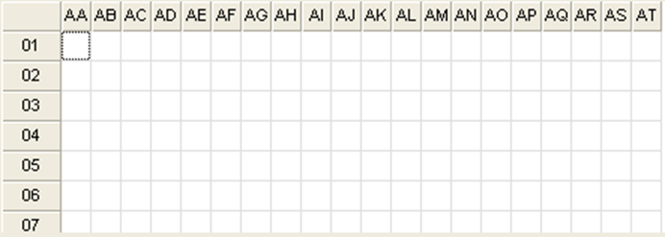

<<ClientName>> approved Manufacturer:

Panduit

<<ClientName>> approved Grid Label part numbers. The part numbers and sizes listed are a small subset of the number available. For additional information, contact Panduit customer service or refer to the current parts catalog.
Part Number | Description
C850X1100YJJ | Laser/ink jet component label, 8.50" W x 11.0" H, adhesive polyester, white, 1 label/row, 1 labels/sheet, 25 labels/package

Cabinet/Rack Labeling

The floor tile designations are used to identify each cabinet or rack in the data center. The cabinet/rack location is based on which floor tile the right front corner of the cabinet/rack rests upon. Cabinets and racks should have location labels applied to the top and bottom of both the front and rear of the device. These labels should be visible whether doors are closed or opened on the cabinets.

A typical cabinet/rack label would have the following scheme:

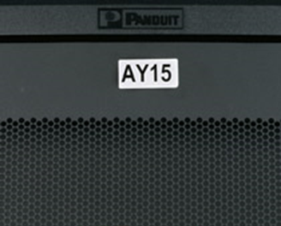

AY15

This identifier would define that the cabinet/rack is located with its right front corner at the intersection of ROW AY and COLUMN 15.

<<ClientName>> approved Manufacturer:

Panduit

<<ClientName>> approved Cabinet/Rack Label part numbers. The part numbers and sizes listed are a small subset of the number available. For additional information, contact Panduit customer service or refer to the current parts catalog.
Printer Type | Laser/InkJet | LS8EQ | Desktop Thermal
Label Area | 2.00” x 1.00” | 2.00” x 1.00” | 2.00” x 1.00”
Label P/N | C200X100YJJ | C200X100YPC | C200X100YPT
 |  |  | C200X100APT
 |  |  | C200X100AMT

Panel Labeling

Once the cabinet/rack identifiers are established, then the various panels in the cabinet/rack should be identified. The designation for the panel positions in a cabinet/rack can be either an alphabetic designation or a two-digit number that represent the rack unit number (RU) where the top-left mounting screw lands in the cabinet/rack. Using the RU method provides the data center manager with greater flexibility since it allows for panels and equipment to be added or removed later and not disrupt the designation of panel identifiers.

A typical panel label would have the following scheme:

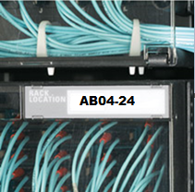

AB04-24

This identifier would define that the top left mounting screw of the panel is located at the 24th rack unit position in the cabinet/rack located grid AB04 in the data center.

<<ClientName>> approved Manufacturer:

Panduit

<<ClientName>> approved Panel Label part numbers. The part numbers and sizes listed are a small subset of the number available. For additional information, contact Panduit customer service or refer to the current parts catalog.
Printer Type | Laser/InkJet | LS8EQ | Desktop Thermal
Label P/N | C100X050YJJ | C100X050YPC | C100X050APT
 |  |  | C100X050A0T

Port Labeling

Establish identifiers for each port on a panel. Port identifiers are very important in that they will define the connectivity of cabling within the data center infrastructure.

Many patch panels come from the factory with numbers already screen-printed above the ports. If this is the case, then there is no need to re-label those patch panels. If the patch panels are not pre-printed with port numbers, then labels will need to be created to identify the port numbers.

The numbering sequence should proceed from left to right and top to bottom for all ports on a patch panel. The number of digits used for all numbers on a patch panel should be consistent with the total number of ports on that patch panel.

Example: a 48-port patch panel should be labeled 01 through 48 and a 144-port patch panel should be labeled 001 through 144.

A typical port label would have the following scheme:

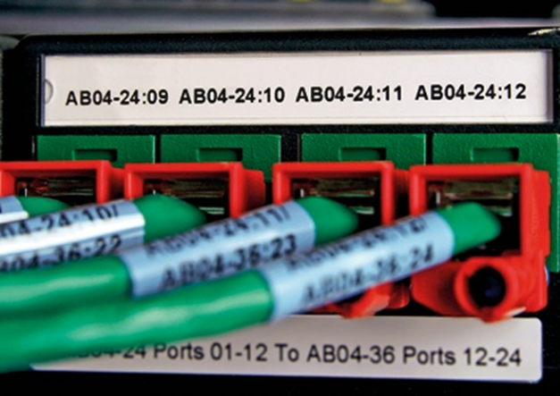

AB04-24:12

This identifier can be decoded to define that this is port 12 located on panel 24 in cabinet/rack AB04.

This is somewhat redundant information given that the cabinet/rack and panel are clearly identified and are not usually required information on the port label since the cabinet/rack and panel are apparent to the viewer who is standing at the location of the port.

Therefore, a typical port label would have the following scheme:

12

This identifier defines that this is port 12.

<<ClientName>> approved Manufacturer:

Panduit

<<ClientName>> approved Port Label part numbers. The part numbers and sizes listed are a small subset of the number available. For additional information, contact Panduit customer service or refer to the current parts catalog.
Printer Type | Laser/InkJet
Cable Type | Copper | Copper | Copper | Copper | Fiber
Label Style | Adhesive | Adhesive | Non-Adhesive | Non-Adhesive | Adhesive
Number of Ports | 4 | 6 | 4 | 6 | n/a
Label P/N | C261X030FJJ | C379X030FJJ | C261X035Y1J | C390X030Y1J | C400X100YJJ
Printer Type | LS8EQ
Cable Type | Copper | Copper | Copper | Copper | Fiber
Label Style | Adhesive | Adhesive | Non-Adhesive | Non-Adhesive | Adhesive
Number of Ports | 4 | 6 | 4 | 6 | n/a
Label P/N | C252X030FJC | C379X030FJC | C261X035Y1C |  | T100X000VPC-BK
Printer Type | Desktop Thermal
Cable Type | Copper | Copper | Fiber
Label Style | Adhesive | Adhesive | Adhesive
Number of Ports | 4 | 6 | n/a
Label P/N | C252X030YPT  C252X030APT | C379X030YPT  C379X030APT | C350X100YJT
Printer Type | MP300
Cable Type | Copper | Copper | Copper |  | Fiber
Label Style | Adhesive | Adhesive | Non-Adhesive |  | Adhesive
Number of Ports | 4 | 6 | 4 |  | n/a
Label P/N | T038X000VPM-BK | T038X000VPM-BK | C261X035Y1M |  | T100X000VPM-BK

Cable Labels

Cables labels are identified with information that defines the connection between the near end panel connection and the far end panel connection.

The near end connection is the connection that is closest to the Main Distribution Area (MDA) in the network topology. A near end connection identifier would consist of the cabinet/rack location, panel location, and port location.

The far end connection identifier would consist of the cabinet/rack location, panel location, and port location.

A typical cable label would have information in the following scheme:

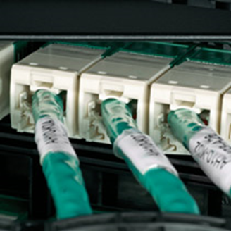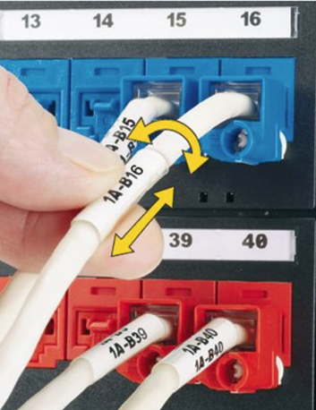

AB04-24:01/AB07-36:13

This identifier would be decoded to define the cable connects between cabinet AB04 panel 24 port 01 going to cabinet AB07 panel 36 port 13. The far end of the cable would have a label that would have the same information.

<<ClientName>> approved Manufacturer:

Panduit

<<ClientName>> approved Cable Label part numbers. The part numbers and sizes listed are a small subset of the number available. For additional information, contact Panduit customer service or refer to the current parts catalog.

Printer Type | Laser/Ink Jet
Cable Type | Copper | Copper | Fiber | Fiber | Fiber
Cable Diameter | Cat5/5e/6 | 10G UTP/STP | 2mm/3mm | Duplex 3mm | Dia. (0.24" to 0.48")
Marker Type | Self-Laminating | Self-Laminating | Flag | Flag | Self-Laminating
Label P/N | S100X150YAJ  R100X150X1J | S100X225YAJ  R100X225X1J | F102X220FJJ | F102X220FJJ | S100X225YAJ  R100X225X1J
Printer Type | LS8EQ
Cable Type | Copper | Copper | Fiber | Fiber | Fiber
Cable Diameter | Cat5/5e/6 | 10G UTP/STP | 2mm/3mm | Duplex 3mm | Dia. (0.24" to 0.48")
Marker Type | Self-Laminating | Self-Laminating | Self-Laminating for Label-Core | Self-Laminating for Label-Core | Self-Laminating
Label P/N | S100X150VAC  R100X150V1C | S100X225VAC  R100X225V1C | S100X160VAC | S100X220VAC | S100X225VAC  R100X225V1C
Printer Type | Desktop Thermal
Cable Type | Copper | Copper | Fiber | Fiber | Fiber
Cable Diameter | Cat5/5e/6 | 10G UTP/STP | 2mm/3mm | Duplex 3mm | Dia. (0.24" to 0.48")
Marker Type | Self-Laminating | Self-Laminating | Self-Laminating for Label-Core | Self-Laminating for Label-Core | Self-Laminating
Label P/N | S100X150VATYR100X150V1T | S100X225VATYR100X225V1T | S100X150VATY | S100X225VATY | S100X225VATY  R100X225V1T
Printer Type | MP300
Cable Type | Copper | Copper | Fiber | Fiber | Fiber
Cable Diameter | Cat5/5e/6 | 10G UTP/STP | 2mm/3mm | Duplex 3mm | Dia. (0.24" to 0.48")
Marker Type | Self-Laminating | Self-Laminating | Self-Laminating for Label-Core | Self-Laminating for Label-Core | Self-Laminating
Label P/N | S100X150VAM  R100X150V1M | S100X225VAM  R100X225V1M | S100X150VAM | S100X225VAM | S100X225VAM  R100X225V1M
Note | “S” – SELF-LAMINATING TYPE LABEL / ”R” – TURN-TELL TYPE LABEL

Patch Cord/Equipment Cord Labels

Patch cord/equipment cord labels are identified with information that defines the connection between the near end patch panel front connections and the far end patch panel front connections or equipment connections.

A near end connection identifier would consist of the cabinet/rack location, panel location, and port location.

The far end connection identifier would consist of the cabinet/rack location, panel location, and port location.

A typical patch cord label would have information in the following scheme:

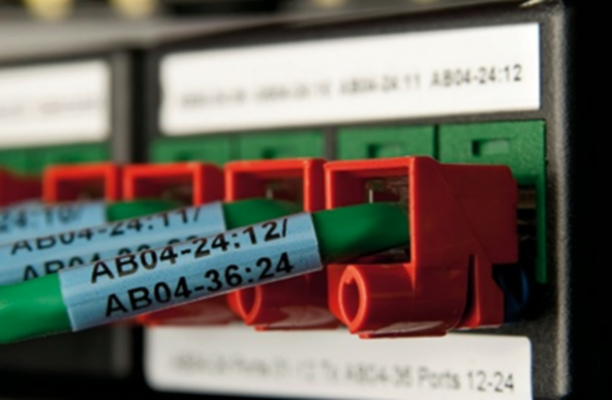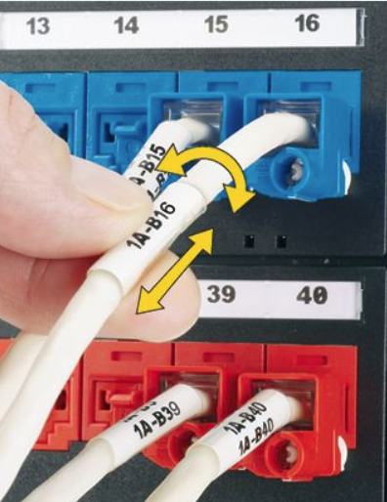

“S” type label – “R” – TURN-Tell type label

AB04-24:12\AB04-36:24

This identifier would be decoded to define the patch cord connection between cabinet AB04 panel 24 port 12 going to the same cabinet panel 36 port 24. The far end of the cable would have a label that would have the same information.

A typical equipment cord label would information in the following scheme:

AB04-24:01\AB04-Tinley2:A

This identifier would be decoded to define the equipment cord connection between cabinet AB04 panel 24 port 01 going to the same cabinet port A on equipment named Tinley2. Rack unit location could be substituted for equipment name if necessary.

<<ClientName>> approved Manufacturer:

Panduit

<<ClientName>> approved Patch and Equipment Label part numbers. The part numbers and sizes listed are a small subset of the number available. For additional information, contact Panduit customer service or refer to the current parts catalog.

Printer Type | Laser/Ink Jet
Cable Type | Copper | Copper | Fiber | Fiber | Fiber
Cable Diameter | Cat5/5e/6 | 10G UTP/STP | 2mm/3mm | Duplex 3mm | Dia. (0.24" to 0.48")
Marker Type | Self-Laminating | Self-Laminating | Flag | Flag | Self-Laminating
Label P/N | S100X150YAJ  R100X150X1J | S100X225YAJ  R100X225X1J | F102X220FJJ | F102X220FJJ | S100X225YAJ  R100X225X1J
Printer Type | LS8EQ
Cable Type | Copper | Copper | Fiber | Fiber | Fiber
Cable Diameter | Cat5/5e/6 | 10G UTP/STP | 2mm/3mm | Duplex 3mm | Dia. (0.24" to 0.48")
Marker Type | Self-Laminating | Self-Laminating | Self-Laminating for Label-Core | Self-Laminating for Label-Core | Self-Laminating
Label P/N | S100X150VAC  R100X150V1C | S100X225VAC  R100X225V1C | S100X160VAC | S100X220VAC | S100X225VAC  R100X225V1C
Printer Type | Desktop Thermal
Cable Type | Copper | Copper | Fiber | Fiber | Fiber
Cable Diameter | Cat5/5e/6 | 10G UTP/STP | 2mm/3mm | Duplex 3mm | Dia. (0.24" to 0.48")
Marker Type | Self-Laminating | Self-Laminating | Self-Laminating for Label-Core | Self-Laminating for Label-Core | Self-Laminating
Label P/N | S100X150VATYR100X150V1T | S100X225VATYR100X225V1T | S100X150VATY | S100X225VATY | S100X225VATY  R100X225V1T
Printer Type | MP300
Cable Type | Copper | Copper | Fiber | Fiber | Fiber
Cable Diameter | Cat5/5e/6 | 10G UTP/STP | 2mm/3mm | Duplex 3mm | Dia. (0.24" to 0.48")
Marker Type | Self-Laminating | Self-Laminating | Self-Laminating for Label-Core | Self-Laminating for Label-Core | Self-Laminating
Label P/N | S100X150VAM  R100X150V1M | S100X225VAM  R100X225V1M | S100X150VAM | S100X225VAM | S100X225VAM  R100X225V1M
Note | “S” – SELF-LAMINATING TYPE LABEL / ”R” – TURN-TELL TYPE LABEL

Patch Panel Connectivity

Patch Panel connectivity defines the connections between the near-end ports and the far-end ports. This labeling can define the connection of a range of ports on a panel or just define the connection for two individual ports.

A typical patch panel connectivity label would have the following scheme:

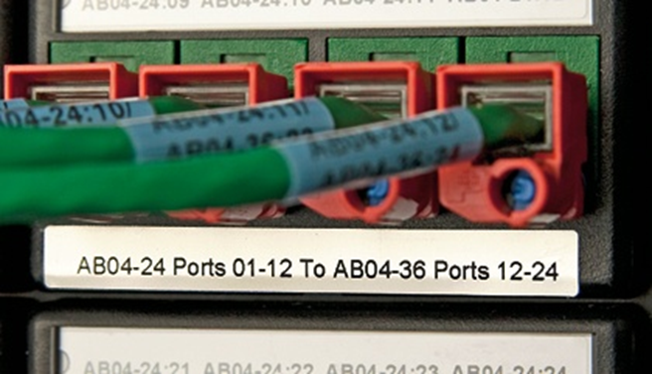

AB04-24:ports 01-12/AB04-36:ports 13-24

This identifier would describe that ports 01 through 12 on panel 24 of cabinet AB04 connect to ports 13 through 24 on panel 36 of cabinet AB04.

<<ClientName>> approved Manufacturer:

Panduit

<<ClientName>> approved Patch Panel Connectivity Label part numbers. The part numbers and sizes listed are a small subset of the number available. For additional information, contact Panduit customer service or refer to the current parts catalog.
Printer Type | Laser/InkJet
Media | Copper | Copper | Fiber
Ports | 4 or less | more than 4 | n/a
Label P/N | C252X030FJJ | C379X030FJJ | C300X100YJJ
Printer Type | LS8EQ
Media | Copper | Copper | Fiber
Ports | 4 or less | more than 4 | n/a
Label P/N | C252X030FJC | C379X030FJC | T100X000VPC-BK
Printer Type | Desktop Thermal
Media | Copper | Copper | Fiber
Ports | 4 or less | more than 4 | n/a
Label P/N | C252X030YPT | C379X030YPT | C350X100YJT
Printer Type | MP300
Media | Copper | Copper | Fiber
Ports | 4 or less | more than 4 | n/a
Label P/N | T038X000VPM-BK | T038X000VPM-BK | T100X000VPM-BK

grounding and bonding

Labeling of the Ground and Bonding system involves the identifications of the Primary Bonding Busbars, Secondary Bonding Busbars, Conductors Connecting Busbars, Conductors Connecting Devices to Busbars and Equalizing Conductors.

The typical scheme for the primary bonding busbar would be:

1-B301-PBB

This identifier can be decoded to define that this is the primary bonding busbar located on floor 1 in space B301.

The typical scheme for a secondary bonding busbar would be:

2-R201-SBB

This identifier can be decoded to define that this is the secondary bonding busbar on floor 2 in space R201.

The typical scheme for the busbar connections would be:

1-B301-RBB/2-R201-SBB

This identifier can be decoded to define that this is the conductor that connects the primary bonding busbar located on floor 1 in space B301 to the secondary bonding busbar on floor 2 in space R201.

<<ClientName>> approved Manufacturer:

Panduit

<<ClientName>> approved Busbar/Busbar Connections Label part numbers. The part numbers and sizes listed are a small subset of the number available. For additional information, contact Panduit customer service or refer to the current parts catalog.

Busbar Connections Labels  Printer Type | Laser/InkJet
Cable Diameter | 18-14 AWG | 12-10 AWG | 8-4 AWG | 2-1 AWG | 1/0-250 MCM
Marker Type | Self-Laminating | Self-Laminating | Self-Laminating | Self-Laminating | Self-Laminating
Label P/N | S100X075YAJ | S100X125YAJ | S100X225YAJ | S100X400YAJ | S100X650YAJ
Printer Type | LS8EQ
Cable Diameter | 18-14 AWG | 12-10 AWG | 8-4 AWG | 2-1 AWG | 1/0-250 MCM
Marker Type | Self-Laminating | Self-Laminating | Self-Laminating | Self-Laminating | Self-Laminating
Label P/N | S100X075VAC | S100X125VAC | S100X225VAC | S100X400VAC | S100X650VAC
Printer Type | Desktop Thermal
Cable Diameter | 18-14 AWG | 12-10 AWG | 8-4 AWG | 2-1 AWG | 1/0-250 MCM
Marker Type | Self-Laminating | Self-Laminating | Self-Laminating | Self-Laminating | Self-Laminating
Label P/N | S100X075VATY | S100X125VATY | S100X225VATY | S100X400VATY | S100X650VATY
Printer Type | MP300
Cable Diameter | 18-14 AWG | 12-10 AWG | 8-4 AWG | 2-1 AWG | 1/0-250 MCM
Marker Type | Self-Laminating | Self-Laminating | Self-Laminating | Self-Laminating | Self-Laminating
Label P/N | S100X075VAM | S100X125VAM | S100X225VAM | S100X400VAM | S100X650VAM
Grounding Busbar Labels  Printer Type | Laser/InkJet
Label P/N | C400X200YJJ
Printer Type | LS8EQ
Label P/N | C200X100YPC
Printer Type | Desktop Thermal
Label P/N | C400X200YJT
Printer Type | MP300
Label P/N | T150X000VPM-BK

Power Cables

Labeling of the power system involves the labeling of the cables feeding power outlet units (POU) with information defining the source of power to the POU. This information would include the distribution panel and the circuit that feeds the POU.

A typical scheme for the power labeling would be:

AB03A-PP21-15

This identifier can be decoded to define that this is the power cable that connects POU A located in rack/cabinet AB03 to circuit breaker 15 in power panel 21.

<<ClientName>> approved Manufacturer:

Panduit

<<ClientName>> approved Power Cable Label part numbers. The part numbers and sizes listed are a small subset of the number available. For additional information, contact Panduit customer service or refer to the current parts catalog.

Busbar Connections Labels  Printer Type | Laser/InkJet
Cable Diameter | 18-14 AWG | 12-10 AWG | 8-4 AWG | 2-1 AWG | 1/0-250 MCM
Marker Type | Self-Laminating | Self-Laminating | Self-Laminating | Self-Laminating | Self-Laminating
Label P/N | S100X075YAJ | S100X125YAJ | S100X225YAJ | S100X400YAJ | S100X650YAJ
Printer Type | LS8EQ
Cable Diameter | 18-14 AWG | 12-10 AWG | 8-4 AWG | 2-1 AWG | 1/0-250 MCM
Marker Type | Self-Laminating | Self-Laminating | Self-Laminating | Self-Laminating | Self-Laminating
Label P/N | S100X075VAC | S100X125VAC | S100X225VAC | S100X400VAC | S100X650VAC
Printer Type | Desktop Thermal
Cable Diameter | 18-14 AWG | 12-10 AWG | 8-4 AWG | 2-1 AWG | 1/0-250 MCM
Marker Type | Self-Laminating | Self-Laminating | Self-Laminating | Self-Laminating | Self-Laminating
Label P/N | S100X075VATY | S100X125VATY | S100X225VATY | S100X400VATY | S100X650VATY
Printer Type | MP300
Cable Diameter | 18-14 AWG | 12-10 AWG | 8-4 AWG | 2-1 AWG | 1/0-250 MCM
Marker Type | Self-Laminating | Self-Laminating | Self-Laminating | Self-Laminating | Self-Laminating
Label P/N | S100X075VAM | S100X125VAM | S100X225VAM | S100X400VAM | S100X650VAM

Safety, Fire and Security

Maintaining a safe workplace is essential to the proper operation of the data center. There are many potentially dangerous systems present in a data center such as fire suppressant systems, cooling systems, and power systems.

The following pre-printed labels can be installed in the data center.
Area | Part # | Example
ELECTRICAL HAZARDS | Safety Signs  - PPS0305W2200  - PPS0305W2100  - PVS0305W2102Y  - PPS0710D73 | 
 | Voltage Markers  - PCV-120CY  - PCV-480BY | 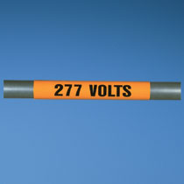
PIPING | - T400X000VQ1Y  - T400X000VS1Y  - T400X000VU1Y  T400X000VX1Y | 
SECURITY | - PSL-DCJB  - PSL-DCPLE  - FLCCLIW-X  - PSL-LCAB  - SKUSBC  - SKUSBA-V  - SKRJ45RD-X  - SKMKEY | 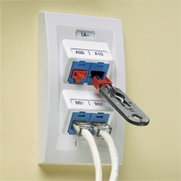

EXECUTION

GENERAL

Upon completion of work, a Registered Communications Distribution Designer (RCDD) shall submit as-built drawings to the Owner and Engineer, and the Contractor shall input the cabling data into the cable management software.

Provide any necessary screws, anchors, clamps, tie wraps, support hardware, etc. necessary to facilitate the installation of the identification communication system.

Furnish any special installation equipment or tools necessary to properly complete the installation.

Failure to follow the appropriate guidelines may require the installer to provide additional material and labor required to bring the installation back into alignment with the guidelines and to correct, any and all, damage to the cables by the installer during the implementation.

All techniques and fixtures used in the installation must allow for easy maintenance of, and ready access to, all components for test measurements.

No self-tapping screws shall be used.

All parts shall be made of corrosion resistant material, such as plastic, anodized aluminum or brass.

All materials used in installation shall be resistant to fungus growth and moisture deterioration.

SYSTEM ADMINISTRATION

All components of the installed system shall be uniquely identified by location, function, unit, and sub-unit.

Each location shall be identified by a unique alphanumeric identifier.

Each equipment enclosure in the building shall be assigned a unique alphanumeric identifier.

Each adapter module installed in each distribution or interconnect enclosure shall be identified by an alphanumeric identifier.

All conduits, trays, and pathways shall be identified by a unique alphanumeric identifier.

Optical fiber cables shall be identified by a textual label, which indicates its type, strand count, point of origin, and termination.

Supply a Cable Identification Matrix.

Supply all records in compliance with ANSI/TIA-606.

Provide a database, compliant with Open Database Connectivity (ODBC), for administration of the Structured Cabling System described herein.

IDENTIFICATION

Prior to the installation or termination of cabling, confirm all specific labeling requirements with the Owner or the Owner’s Engineer.

Cables

Mark backbone cables at each endpoint and at all intermediate pull points, access points, and junction boxes. Labels shall indicate the origination and destination identifier, the sheath identifier, and the strand or pair range.

Horizontal cables shall be marked at each end, on the sheath indicating the TR, patch panel and panel port to which the cable is wired.

Faceplates, Patch Panels, and Wiring Blocks

Mark Fiber Distribution Enclosures (FDEs) with adhesive labels that indicate the range of circuits installed within. Label each port with the origination and destination grid identifier and the individual strand ID.

Label patch panels alphabetically or numerically. Individual ports shall come from the factory pre-labeled with a general number designation.

Label each faceplate to indicate, for each cable that it houses, the TR, patch panel, and panel port to which the cable is wired.

Label each wiring block numerically, beginning at the top left of the termination field. Within each block, identify the individual rows alphabetically, beginning at the top left and proceeding sequentially down and to the right. Label each row with the corresponding cable identifier and label each pair or circuit on each cable.

Fit each cable with a self-laminating label, bearing the appropriate cable identifier, that surrounds the outermost jacket. Place the label at each end of the cable, within 3 inches (75 mm) of the end of the sheath.

Fit each equipment enclosure with a self-adhesive label bearing its respective identifier, affixed to the top center of the front and rear doors.

Fit each FDE with a self-adhesive label, bearing its respective identifier in block characters, affixed at the top center of the front and rear faces.

Fit each adapter inside enclosures with a label bearing its identifier, affixed directly adjacent to its shortest side. Rotate characters so that their orientation is kept left to right, top to bottom.

Label conduits and pathways within 0.5 m (18 inches) of each end, where exposed and accessible. It is recommended that additional labeling be provided every 3 m (10 feet) of exposed length.

Fit network equipment with a label, placed in an accessible area on the front and rear, bearing the appropriate identifier, MAC address, and date of installation. The label shall not interfere with the operation of or interface to the unit, nor shall it obscure manufacturer’s labels.
END OF SECTION 27 05 53

